Sensitivity Analysis of MEET-eaters version 5.0

Contents
READ ME 2
Baseline model 3
Sensitivity analysis (OFAT) 10
Boxplots + violin plots of the effect of global variables on type of meals cooked 11
Boxplots + violin plots of agent attributes 16
Heat maps of variables (paired) on percentage enjoying meal and type of meals cooked 20
Cobweb graphs of type of meals cooked for a selection of separate runs 25
Global sensitivity analysis (PAWN) 29
References 30

READ ME
This document contains the sensitivity analysis of the agent-based model MEET-eaters, a social simulation model to explore the respective contribution of food outlet product ranges and household demand to types of meals cooked. The model specifically focusses on dietary protein choices: meat, fish, vegetarian, and plant-based and is tailored toward the Dutch socio-cultural context. The latest version of the model (5.0), on which the sensitivity analysis was performed, can be found in a GitHub repository (Blokhuis and Polhill 2025). A paper is (to be) submitted to PLOS One by October 2025 named “MEET-eaters: An agent-based model of food consumption practices at the household level”, written by: Christa Blokhuis, J. Gareth Polhill, Marga Ocké, Emely de Vet, and Gert Jan Hofstede.

The document starts with an exploration of the model under baseline conditions, which contains graphs that are included in the main paper, as well as additional graphs about separate runs and the population and status distributions. In order to explore the behaviour of the MEET-eaters model, we conducted a sensitivity analysis. Following the suggestion by Broeke et al. (2016), we applied One Factor at A Time (OFAT) in combination with a method for global sensitivity analysis. Based on the outcome of the OFAT, which showed mainly linear, monotonic relationships between parameters and model outcomes, we selected Partial Rank Correlation Coefficient (PRCC) to conduct global sensitivity analysis. Cobweb graphs were created to study the model outcomes over time under different parameter settings, which allowed us to assess resilience of the model. For the OFAT sensitivity analysis, we explored the effect of each parameter on plant-based meals cooked and meal enjoyment. For the PRCC sensitivity analysis we explored the effect of a selection of parameters on type of meals cooked and inventory levels.

Baseline model
The following graphs are additional graphs displaying the behaviour of the baseline model (the model without interventions). More summarizing graphs are presented in the paper. First, for a selection of separate runs, the type of meals cooked over time are plotted against the median over all runs. The graphs show large differences between runs for the number of meals consisting of meat, fish, vegetarian and plant-based protein sources, reflecting the complexity of the model. Second, summarizing graphs of dietary trends (meat-eater, pescatarian, vegetarian, vegan) are plotted over time, showing minimal changes, reflecting homeostasis of the model. Third, the plant share in food outlets is plotted over time, showing some small variations in the second half of the run. Finally, we show the population distribution size and separate runs for the status distributions at the end of a run. The population sizes show bimodal distributions; the status distributions reflect the right-skewed distribution of the accumulated graph presented in the paper but with large inter-run variation.

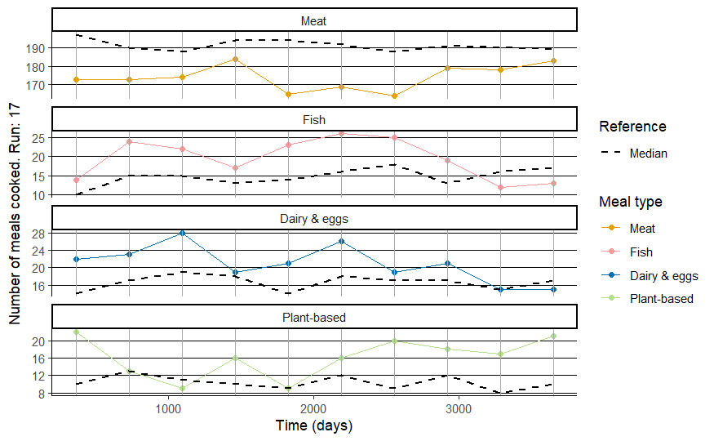
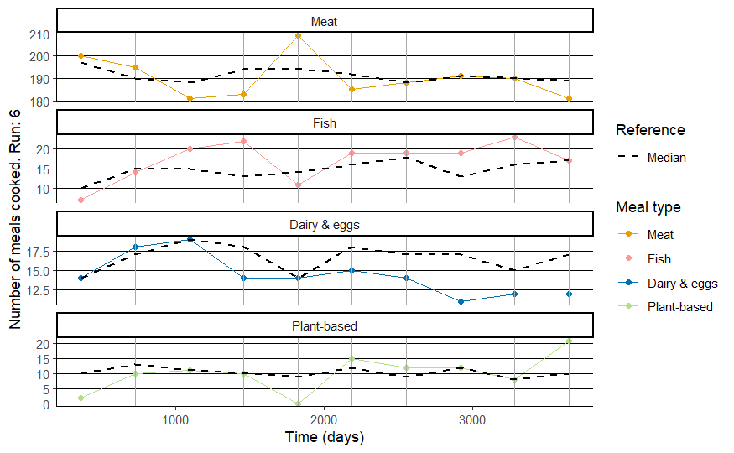

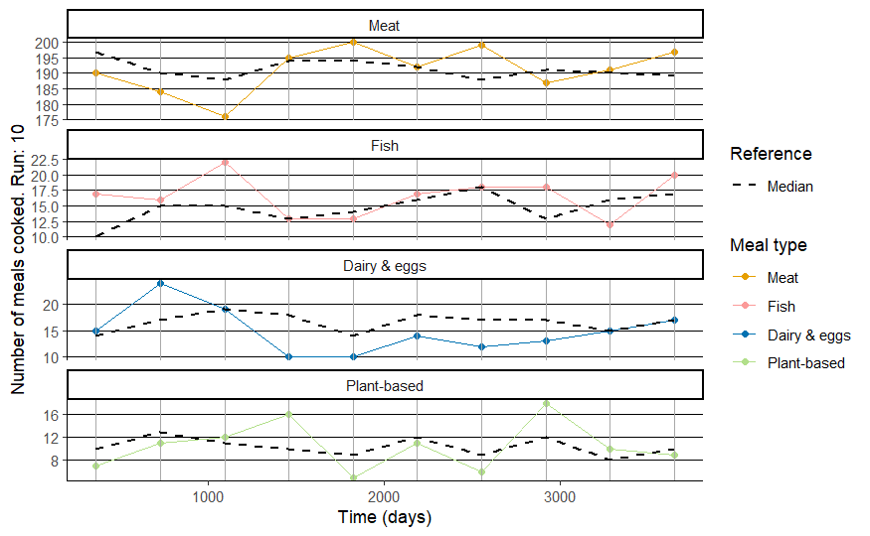
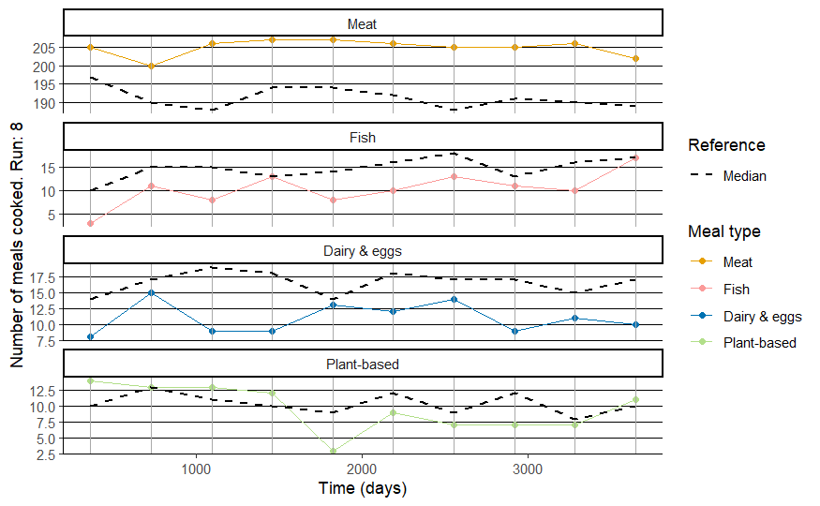
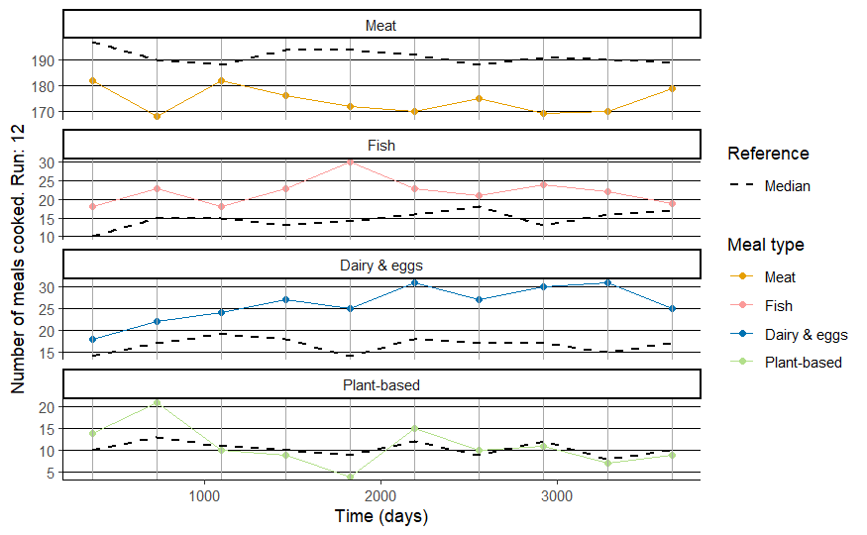
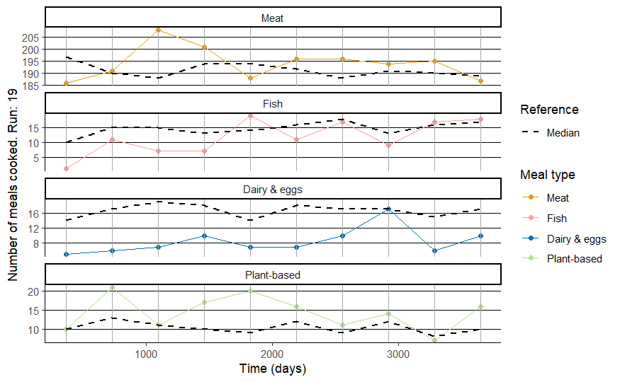
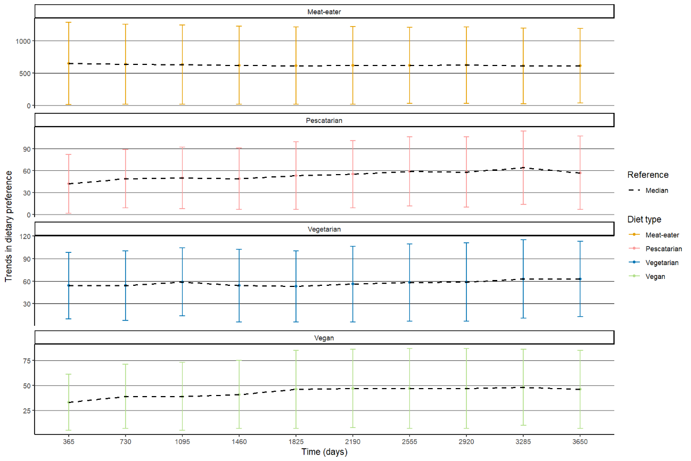
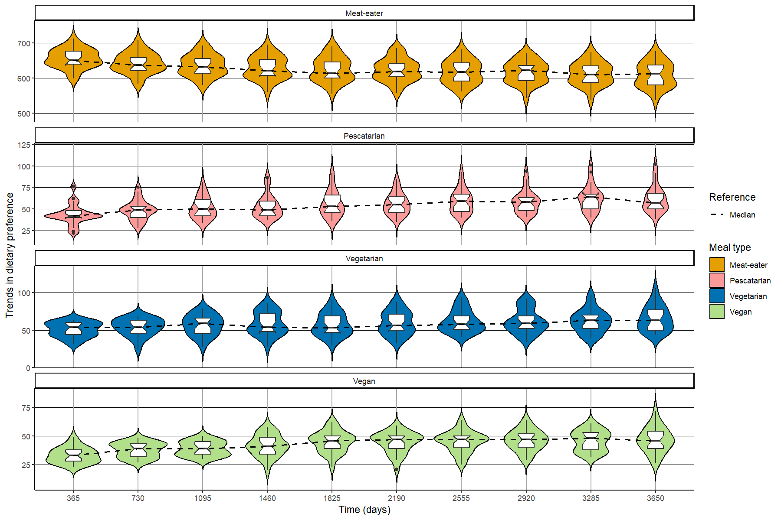

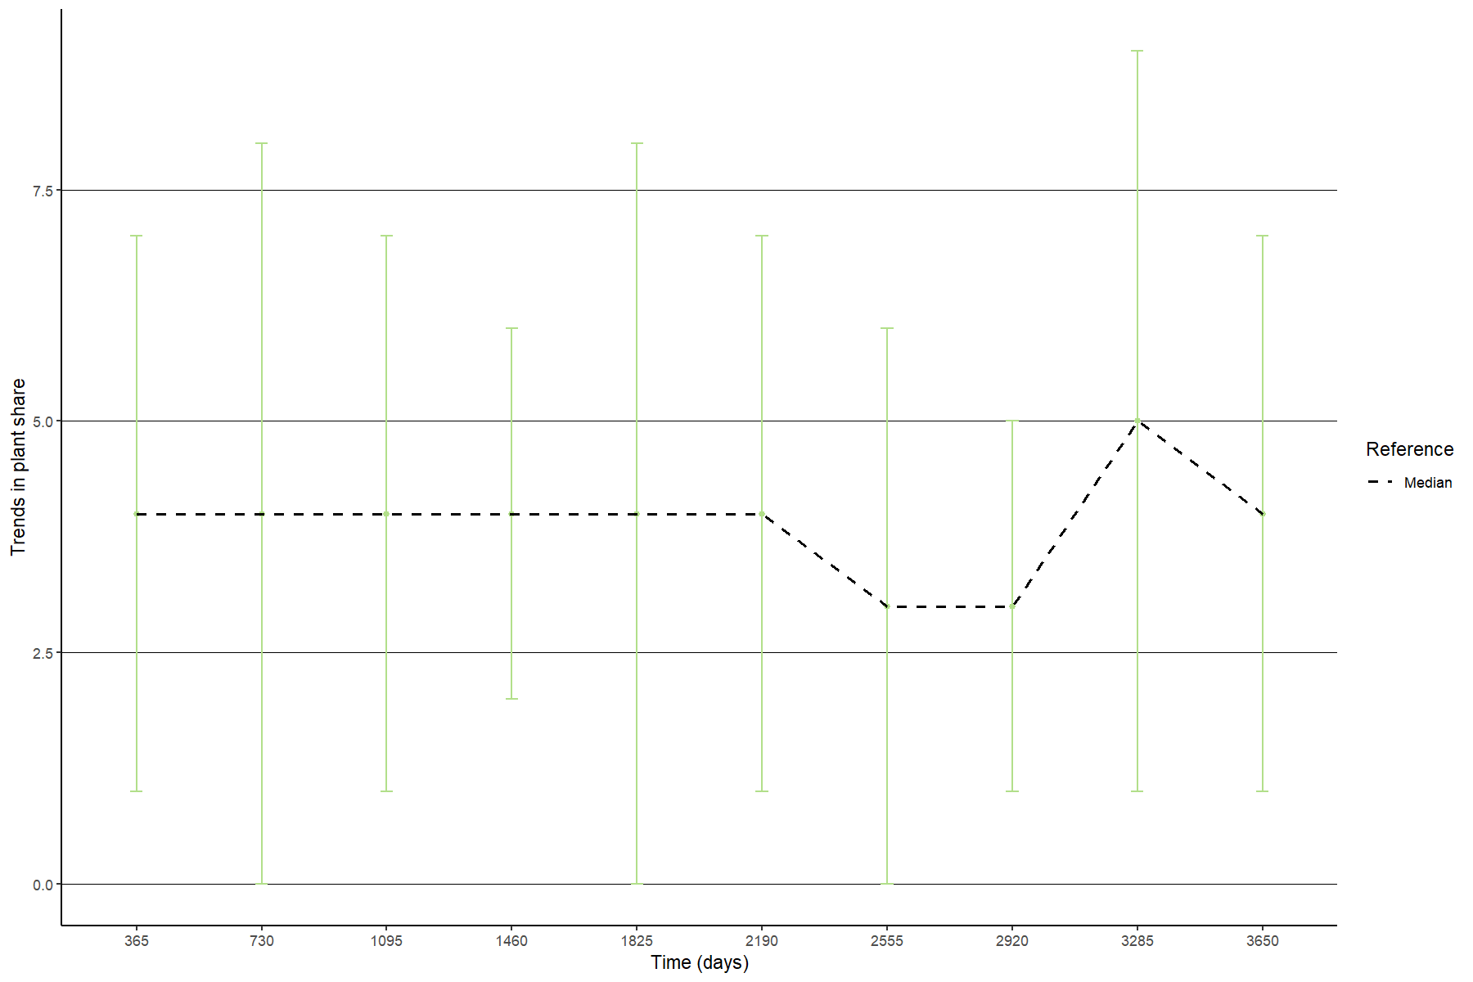
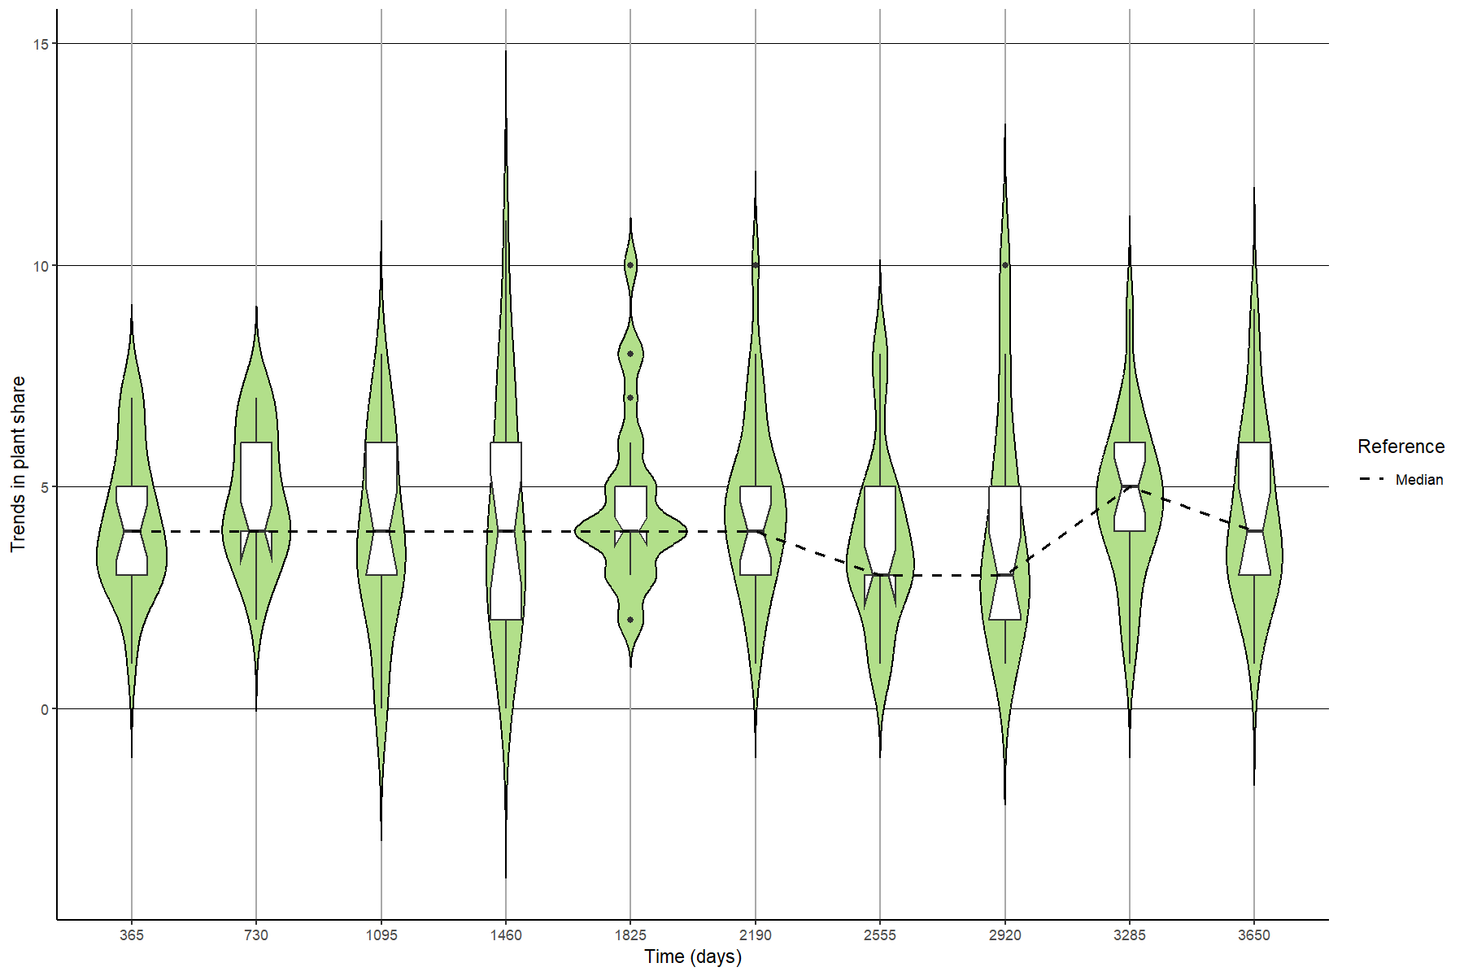

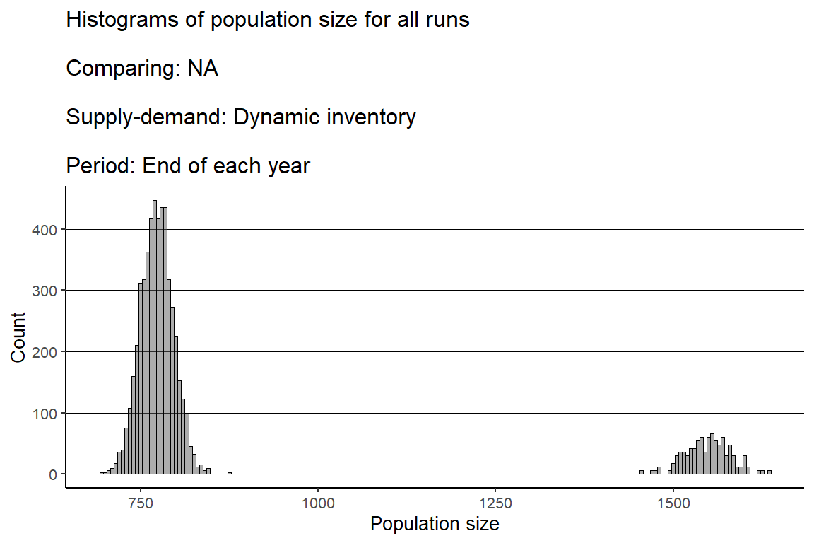
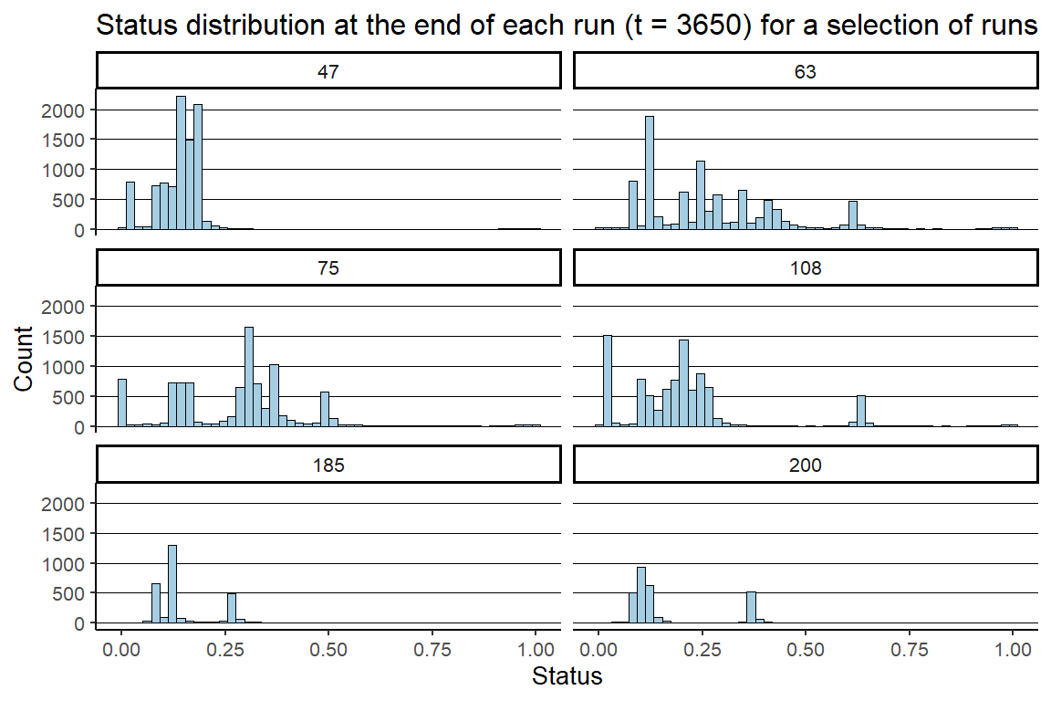

Sensitivity analysis (OFAT)
Sensitivity analysis was conducted using the One Factor at A Time (OFAT) approach. This approach helped us to determine the impact of each individual parameter on model outcome(s) of primary interest with respect to that parameter, and decide upon the default values for the experimental runs. The sensitivity analysis was run with the supply-demand setting “dynamic inventory” and the meal-selection strategy “status-based”. Parameter values of the OFAT sensitivity analysis (Table 1) were compared to model outcomes plant-based meals cooked and percentage meal enjoyment. A summary of the OFAT-based sensitivity analysis is provided in Table 2. For each section, a summary of the results is provided.

Table 1 Table with settings for OFAT sensitivity analysis
parameter | type | values
Initial-nr-food-outlets | factor | 1,5,10
Initial-nr-households | factor | 25, 250,750,1500
Nr-friends | factor | 0,3,6
Restocking-frequency | factor | 1,4,7
Food-outlet-service-area | factor | 20,40,60
Supermarket visits | factor | 1,2,3,4,5,6,7,8
Meal variety | Numeric | 0.1,0.2,0.3,0.4,0.5
Status | Numeric | 0,1
Neophobia level | Numeric | 0,0.1,0.2,0.3,0.4,0.5,0.6,0.7,0.8,0.9,1
Cooking skills | Numeric | 0,0.2,0.4,0.6,0.8,1

Table 2 Summary of OFAT-based sensitivity analysis.
Parameter(s) | Model outcome | Relationship with outcome
Initial number of food outlets | Plant-based meals cooked | No trend
Initial number of households | Plant-based meals cooked | Slight negative trend
Number of friends | Plant-based meals cooked | Negative trend
Restocking frequency | Plant-based meals cooked | No trend
Food outlet service area | Plant-based meals cooked | Positive trend
Supermarket visits | Plant-based meals cooked | No trend
Meal variety | Plant-based meals cooked | No trend
Meal variety | Percentage meal enjoyment | No trend
Status of people preferring vegan | Plant-based meals cooked  Other meals cooked | Positive trend  Negative trend
Neophobia | Plant-based meals cooked | Positive trend
Cooking skills | Plant-based meals cooked  Percentage meal enjoyment | No trend  Logistic growth (S-curve)
Cooking skills & Meal variety | Percentage meal enjoyment | Logistic growth (S-curve)

Boxplots + violin plots of the effect of global variables on type of meals cooked
The initial number of food outlets, length of inventory cycle (=restocking frequency), number of supermarket visits and meal variety all show no effect on plant-based meals cooked. Number of food outlets and meal variety do show a positive trend for meat meals cooked. A slight negative trend appears for the effect of initial number of households (corresponding with population size) and plant-based cooking, while a positive trend is visible for meat meals cooked. Size of food outlet service area, which determines how many people a food outlet will serve, shows a positive trend for plant-based cooking, and a negative trend for meat meals cooked. Number of friends shows a negative trend for all meal choices. However, we should note here that a higher number of friends among the person-agents means that less meals are consumed, because for each dinnertime a higher number of friends can be invited, resulting in larger dinner parties and more houses where no one is home.

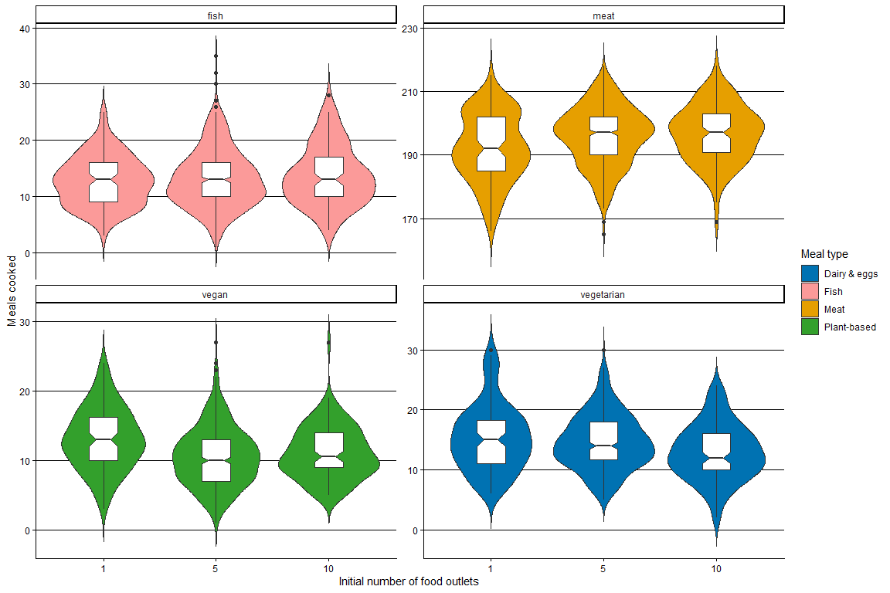
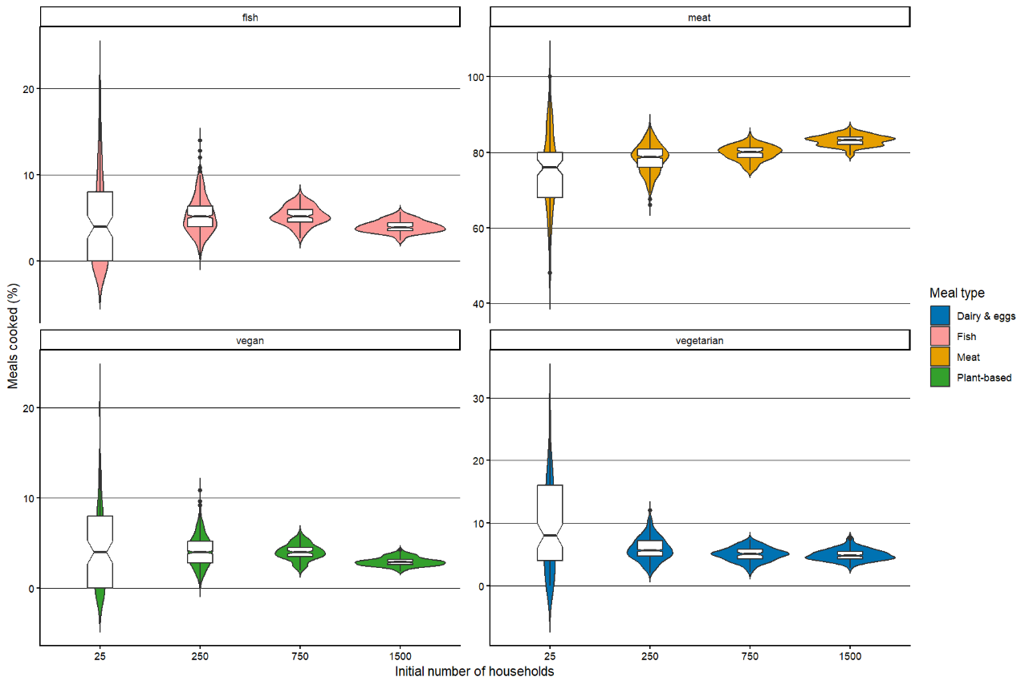

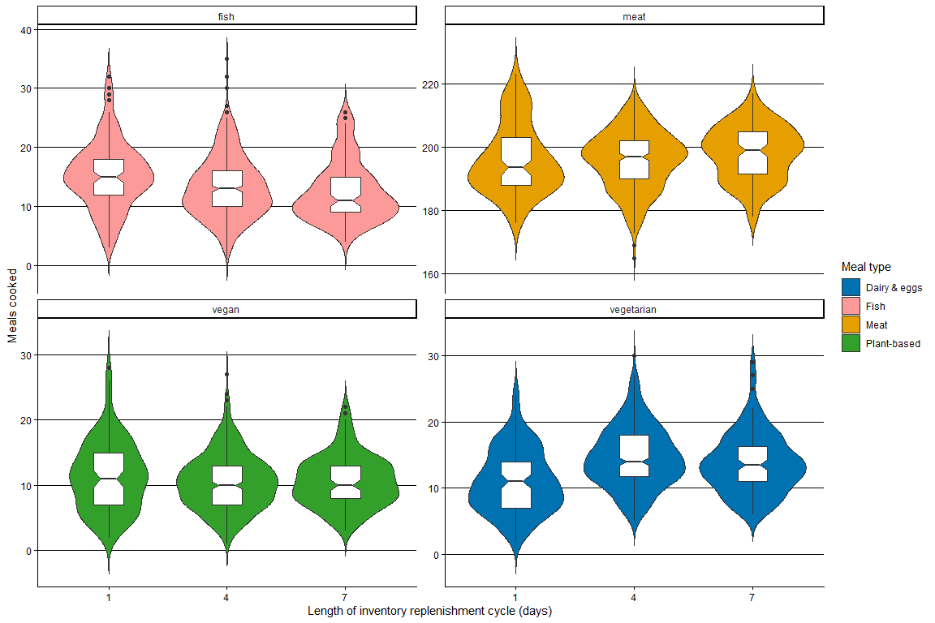
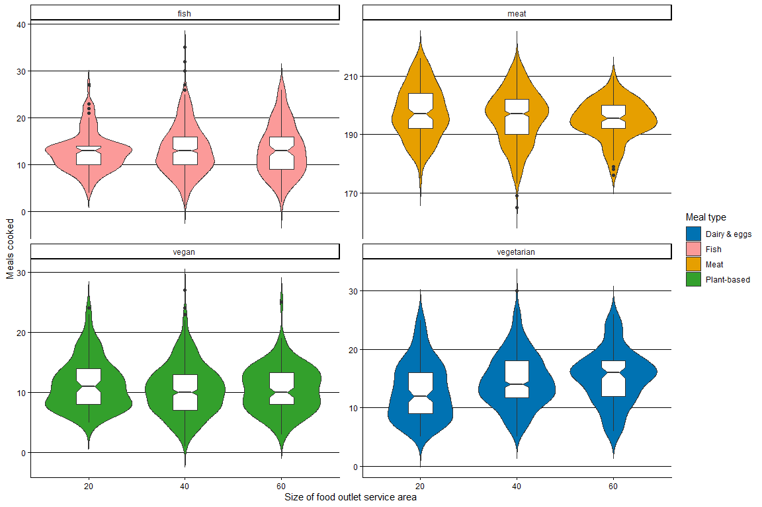

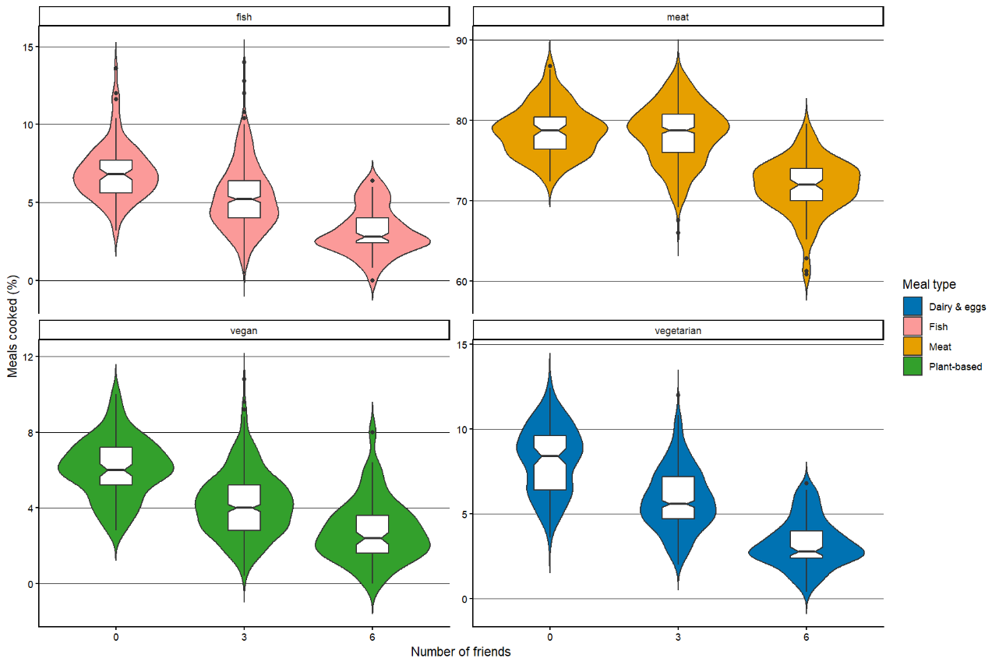
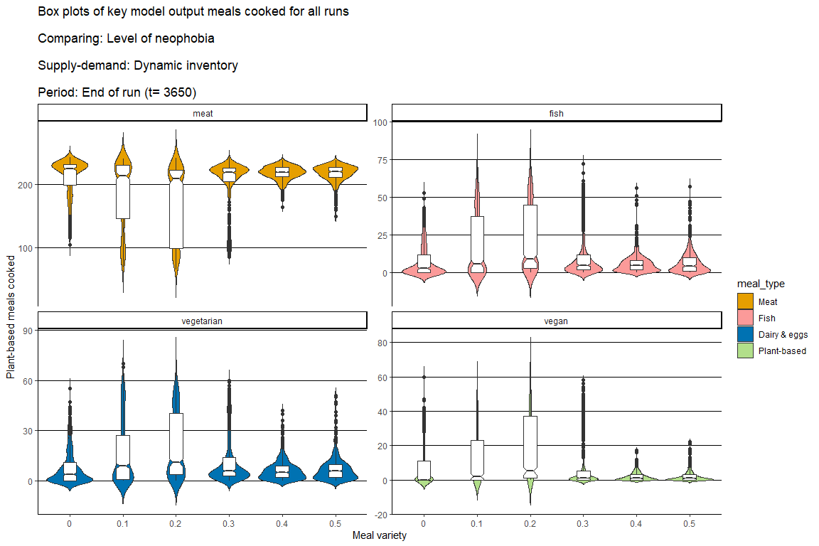
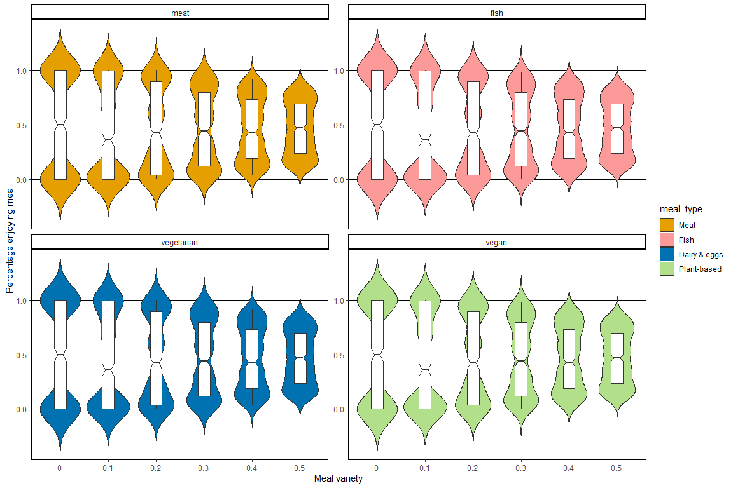
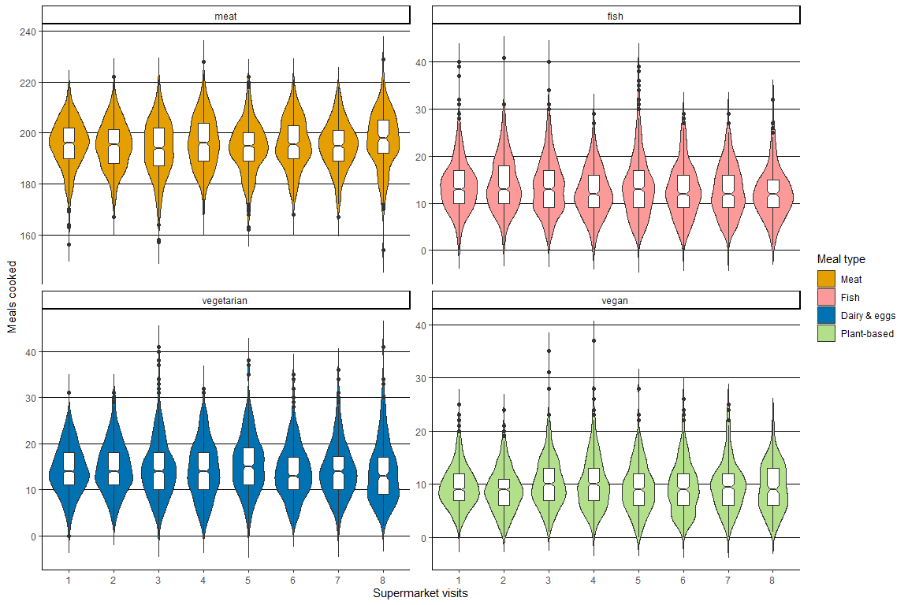

Boxplots + violin plots of agent attributes
Cooking skills displays a logistic growth relationship with the percentage of person-agents enjoying their meal. As the cooking skill of the cook-agent immediately influences the quality of the meal, the outcome is as expected. Status of people preferring a particular diet shows a positive trend with the corresponding meals cooked and a negative trend with other meals cooked, demonstrating the effect of status in meal negotiation. Level of neophobia affects the number of plant-based meals cooked. As this parameter is used in the procedure to obtain groceries, the outcome is to be expected: the more neophobic cook-agents are, the less likely they are to choose an alternative to the majority’s dietary preference, which is meat. The effect of neophobia levels is however visible only with extreme values nearing 1.

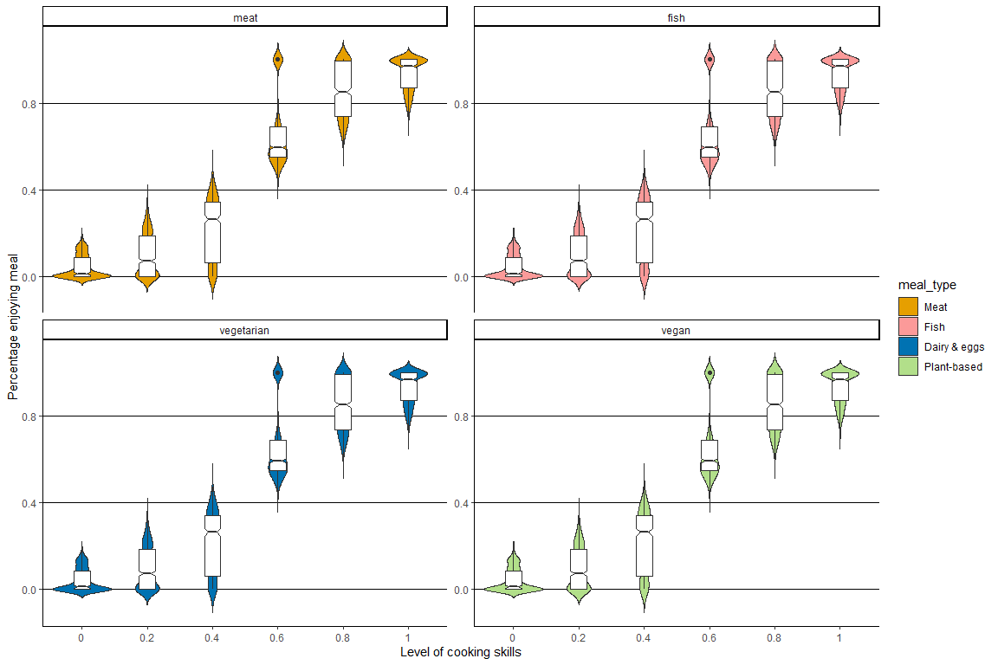

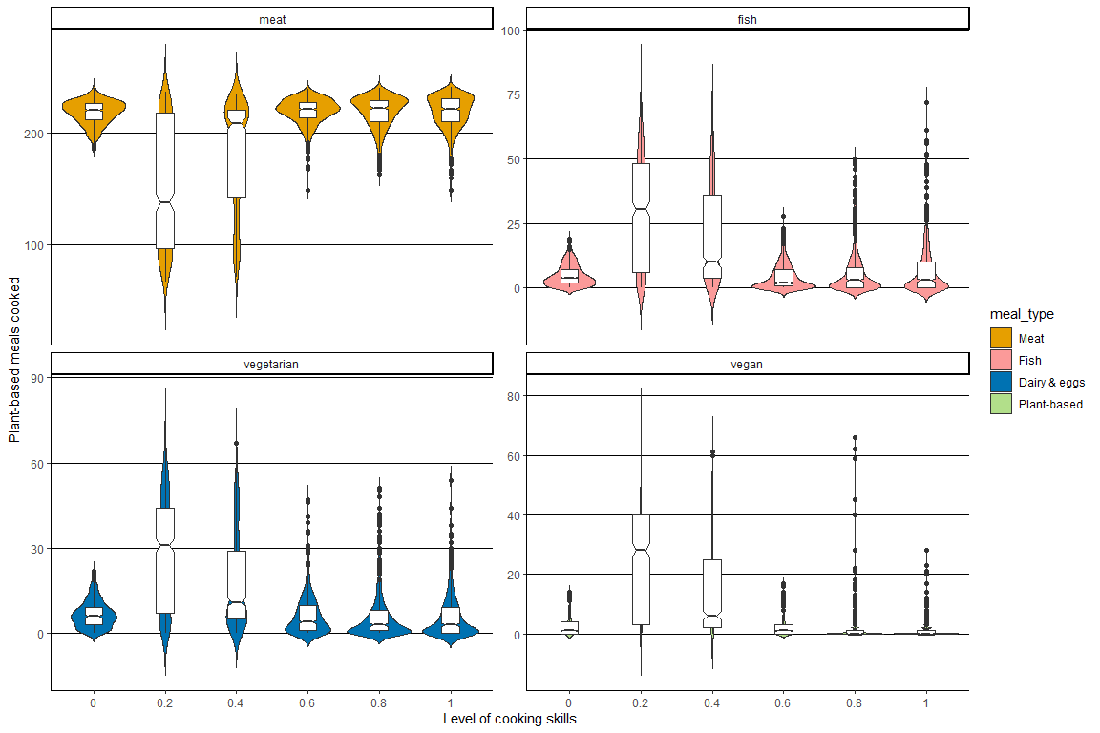
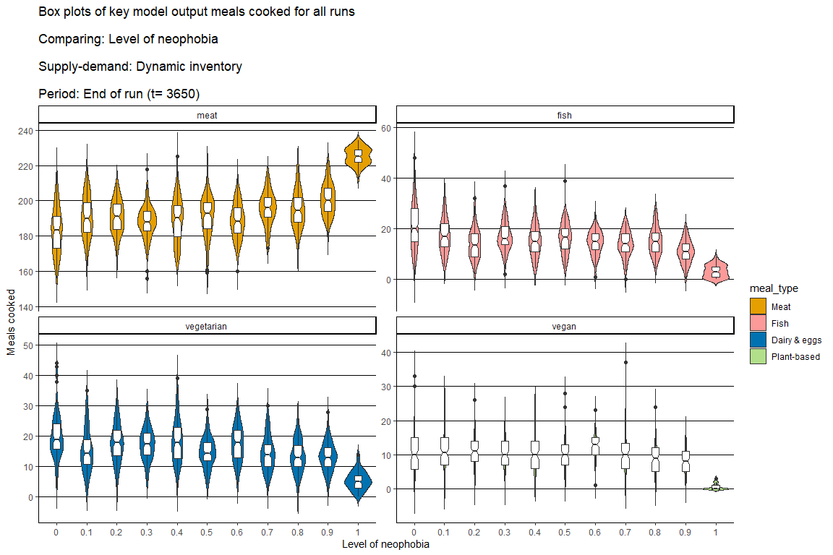
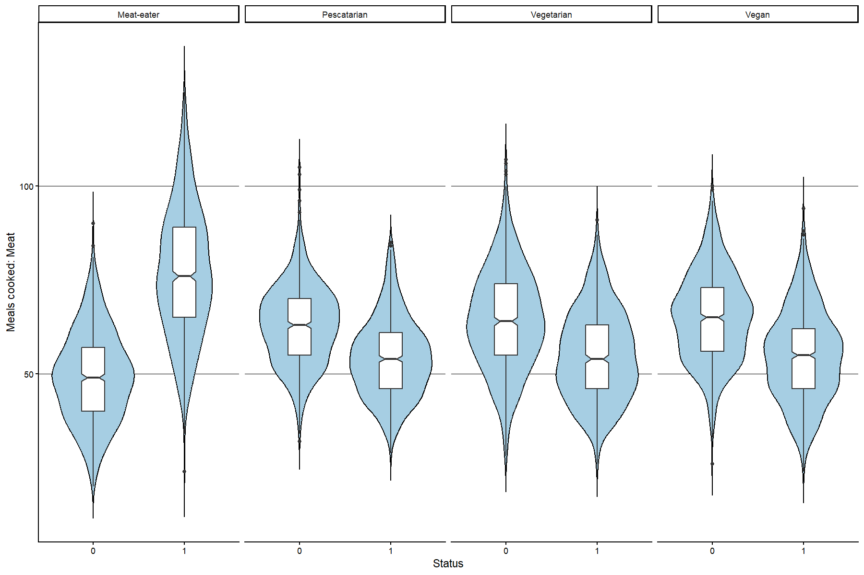

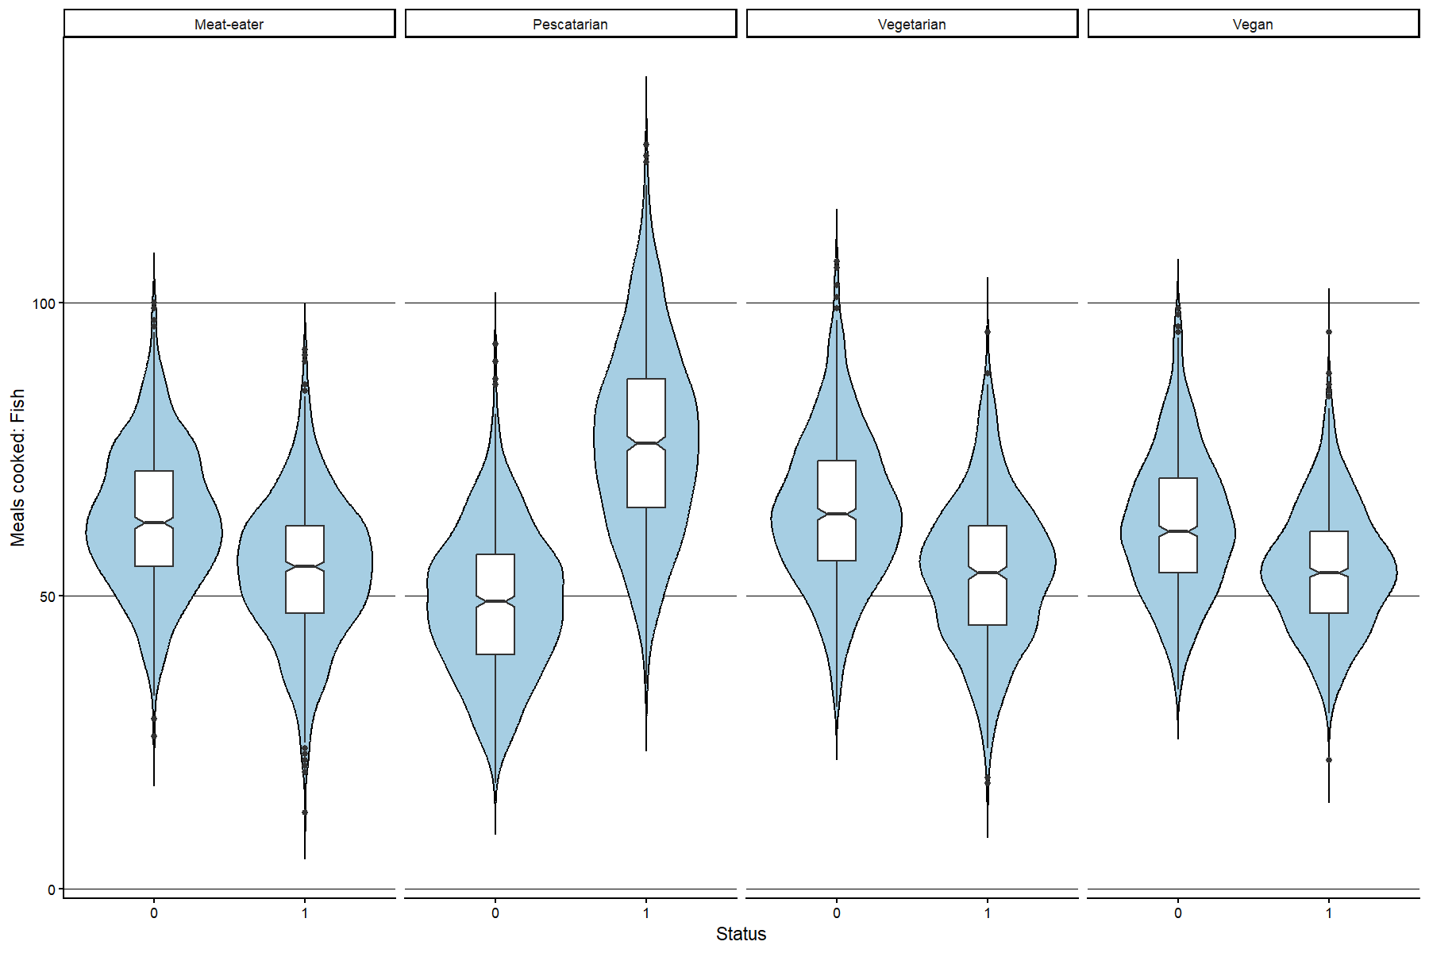
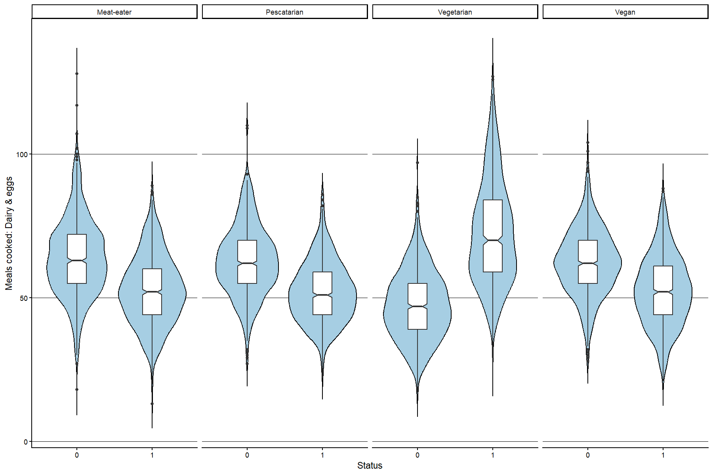

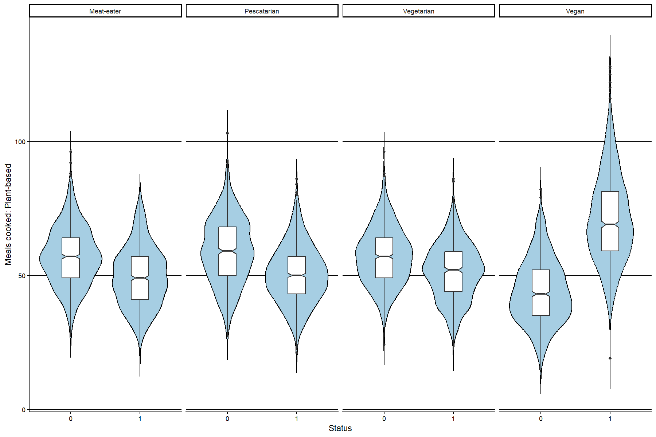

Heat maps of variables (paired) on percentage enjoying meal and type of meals cooked
First, heat maps of cooking skills and meal variety show a clear pattern: the higher the cooking skills of the cook-agent (an agent attribute), and the smaller the variety in meal quality (a global variable), the higher the percentage of person-agents enjoying the meal, irrespective of the type of meal. A clear tipping point seems to be present when cooking skills are 0.6 or higher, which can be explained by the procedure in the model that determines meal enjoyment: in the model, a value for meal quality for 0.55 or higher is considered a positive meal enjoyment. Second, a clear pattern for the relationship between number of food outlets and supermarket visits cannot be discerned across protein sources. However, for meat, a higher number of food outlets and supermarket visits seems to result in more meals cooked, while for the other three dietary protein sources, less food outlets and supermarket visits seem to correspond with more of these meal types cooked.

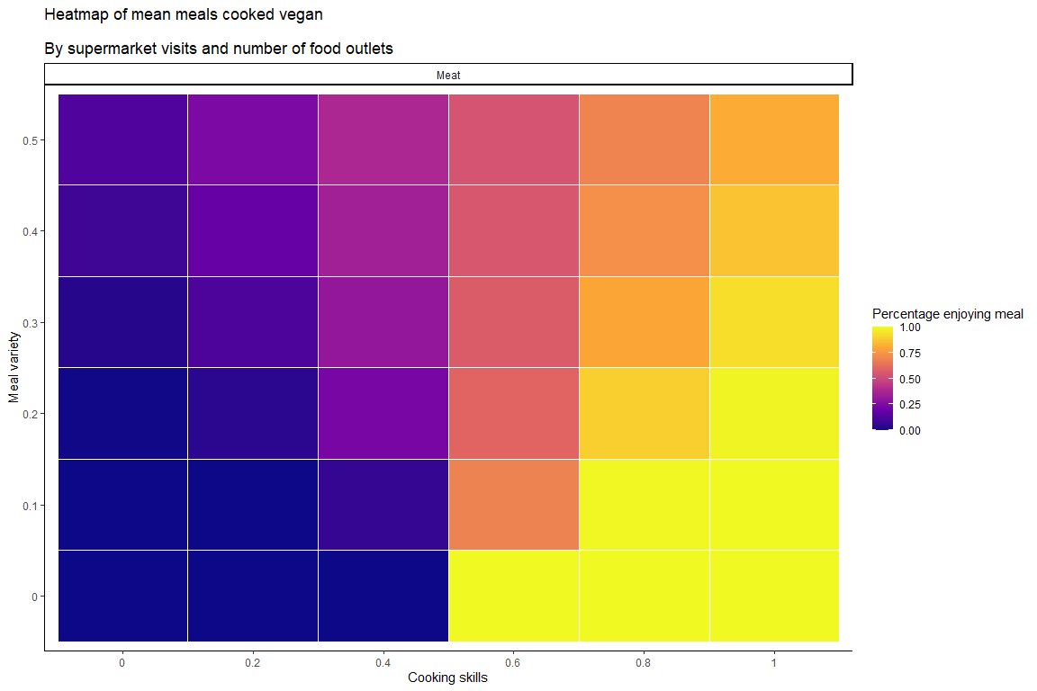
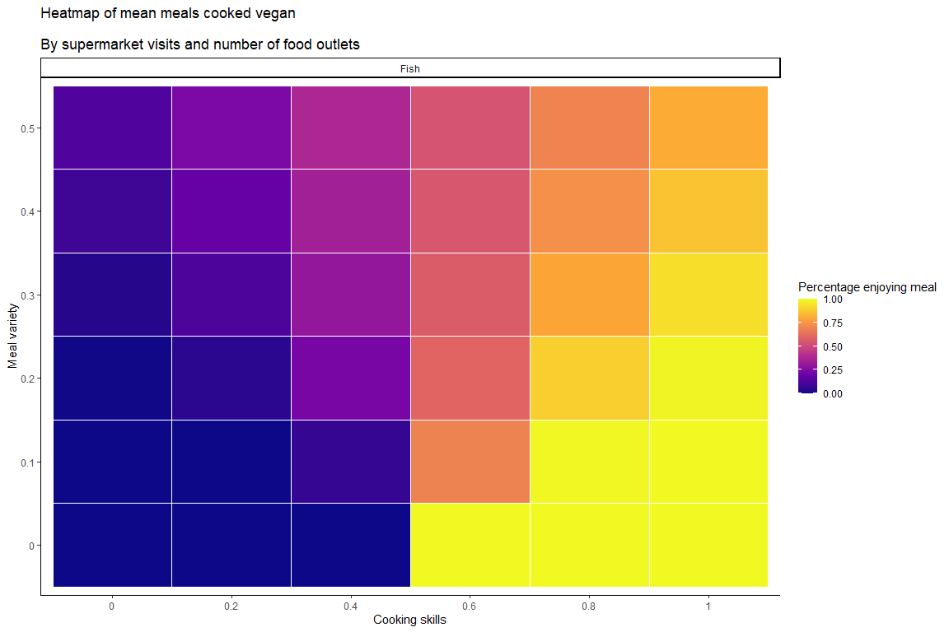

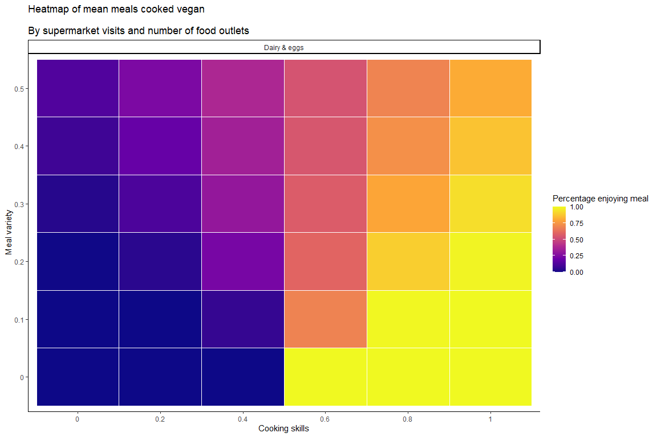
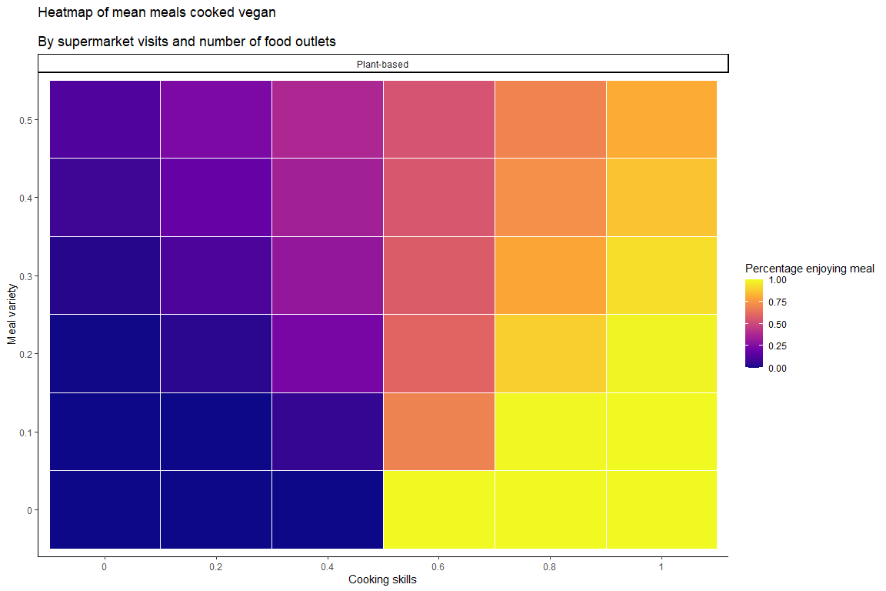

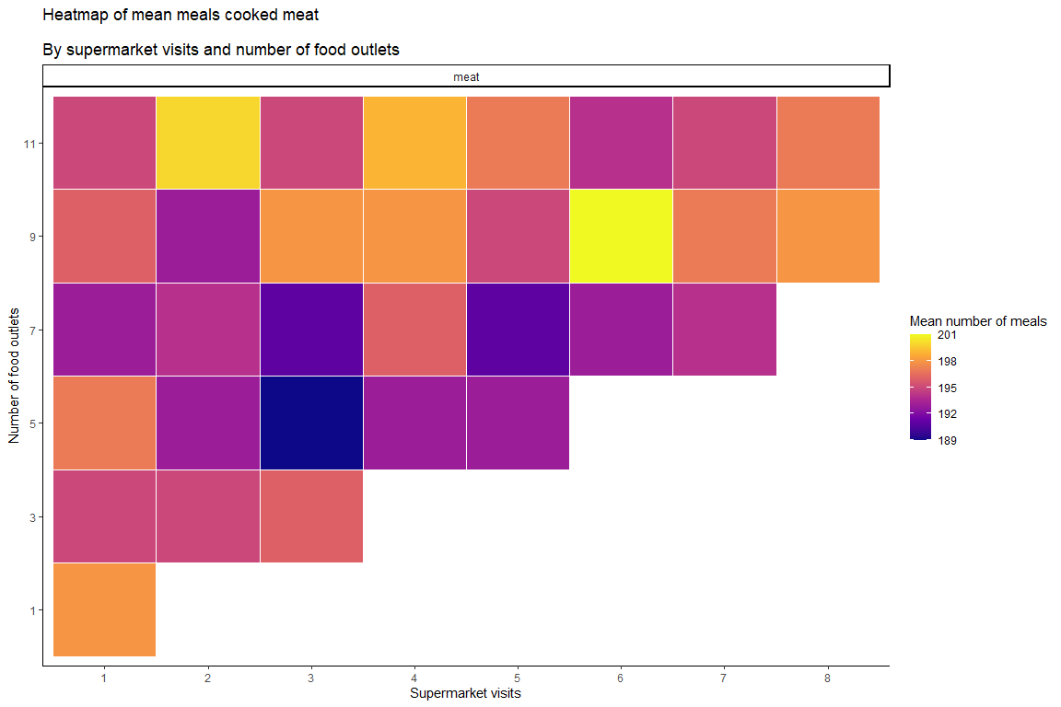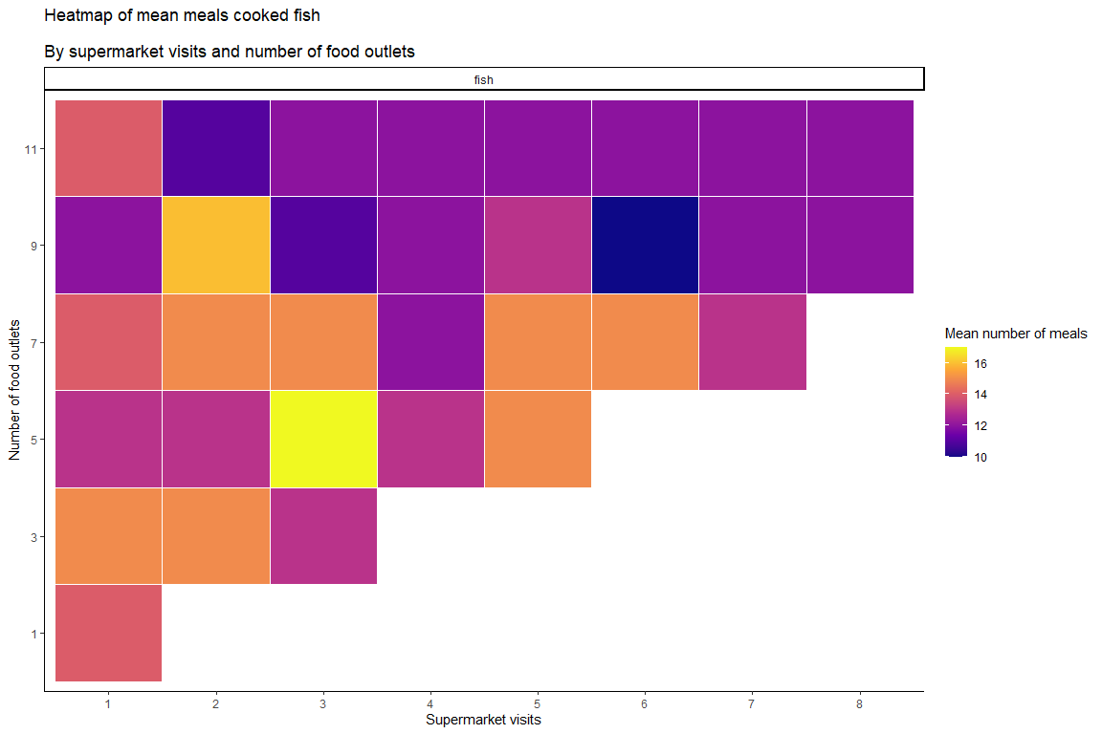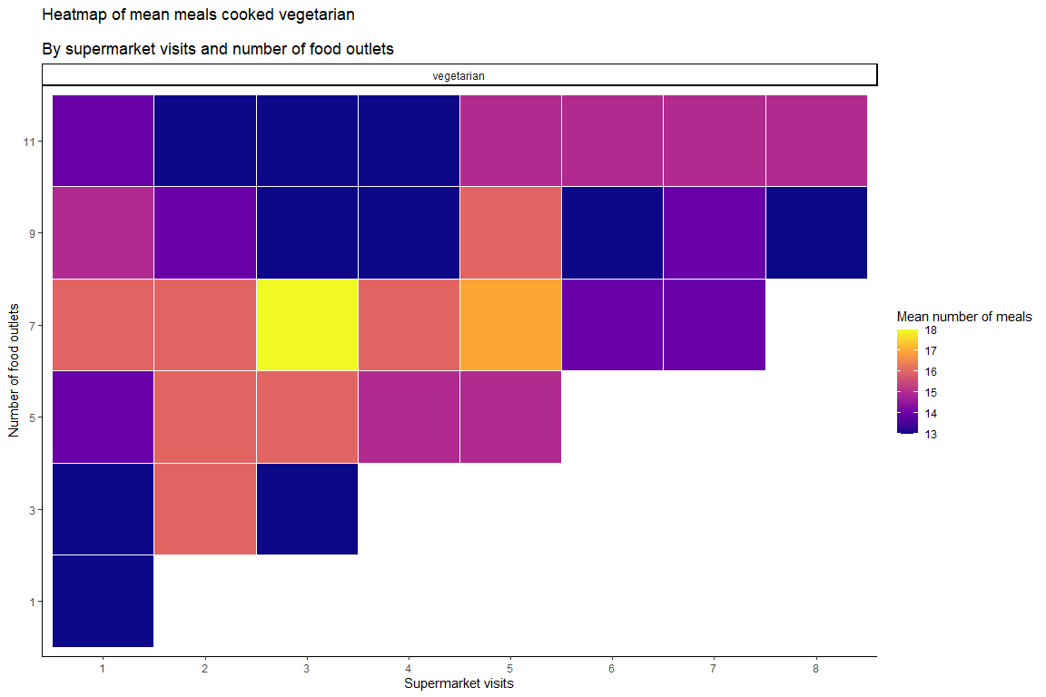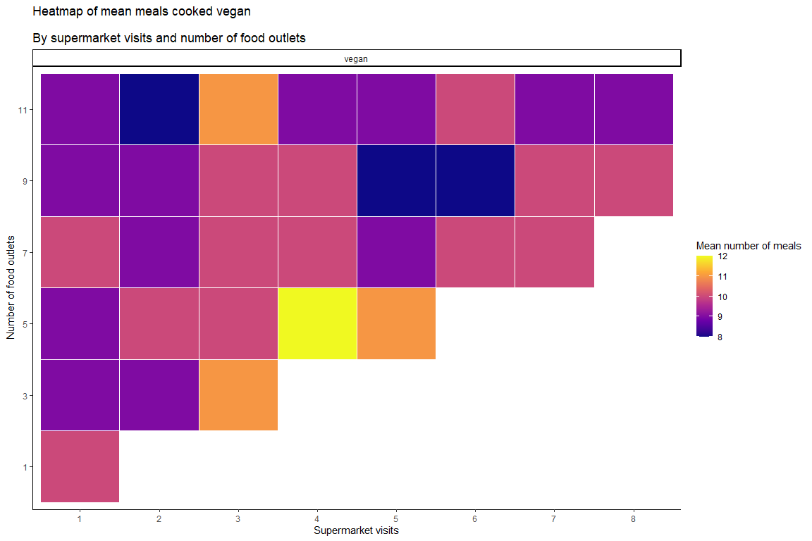

Cobweb graphs of type of meals cooked for a selection of separate runs
These graphs illustrate for selected runs how the meals cooked per meal type relate over time. It becomes clear that in each selected run the meals cooked only vary between around a fixed set of states, and shift into other states at particular moments in time / states, although the number of states is fairly high and variable between runs. Across the runs presented, meat meals cooked seems to show the most ‘states’ – or rather, is the least stable over time. Some runs demonstrate a trend over time, for example the Dairy & eggs graph for run 11 of the number of food outlets data set and the Plant=based graph for run 18 of the number of friends data set.
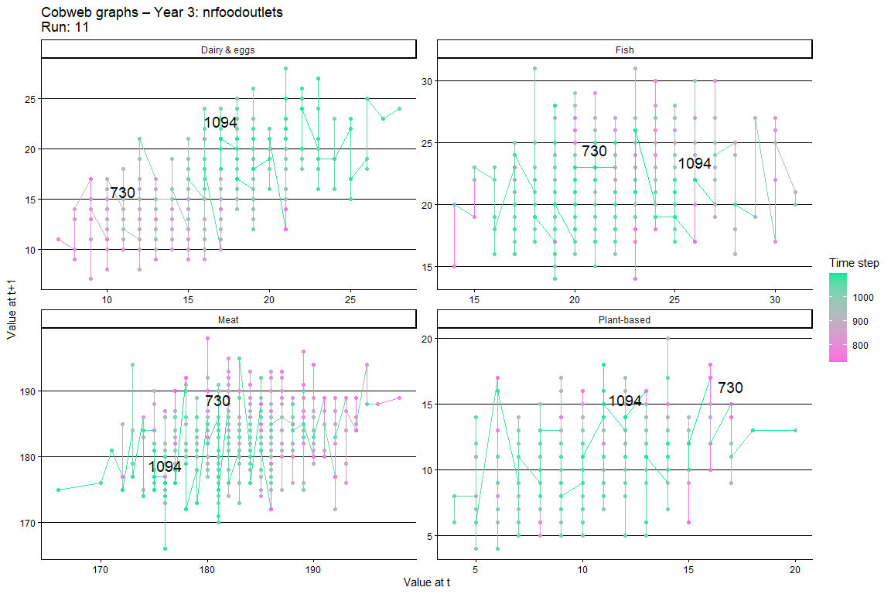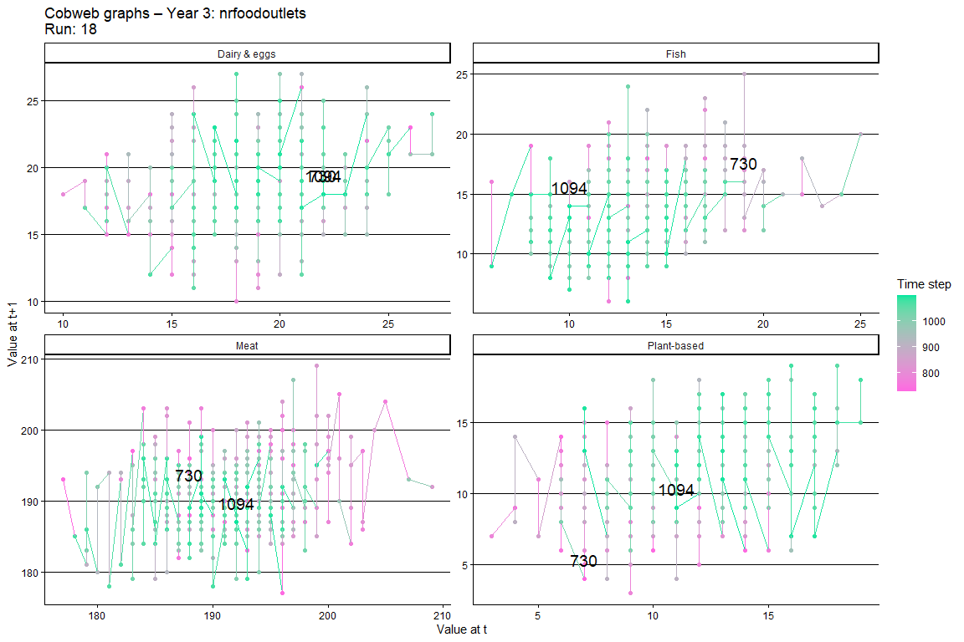
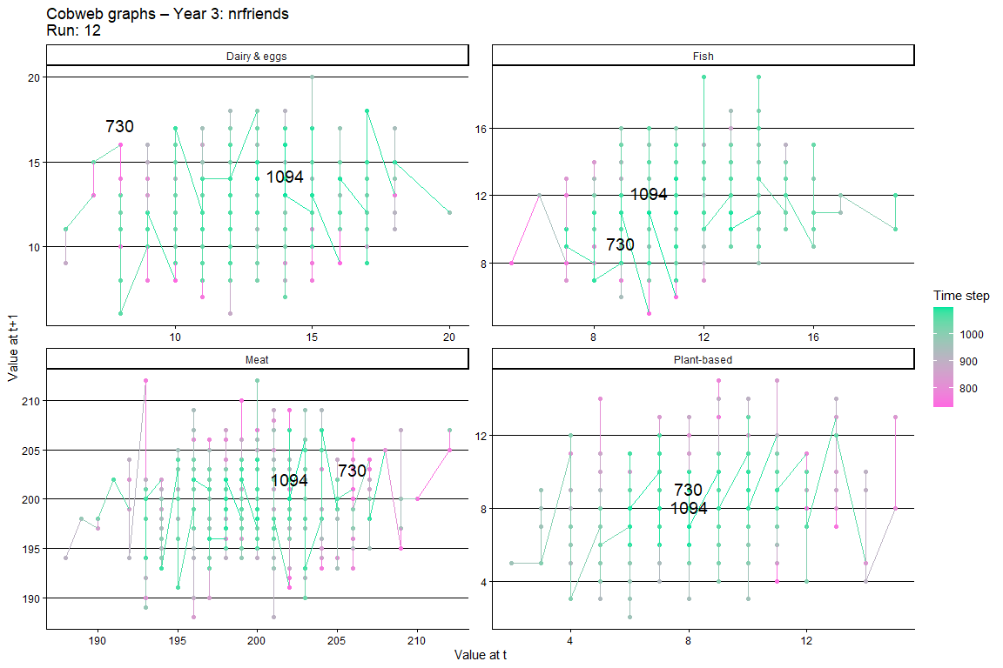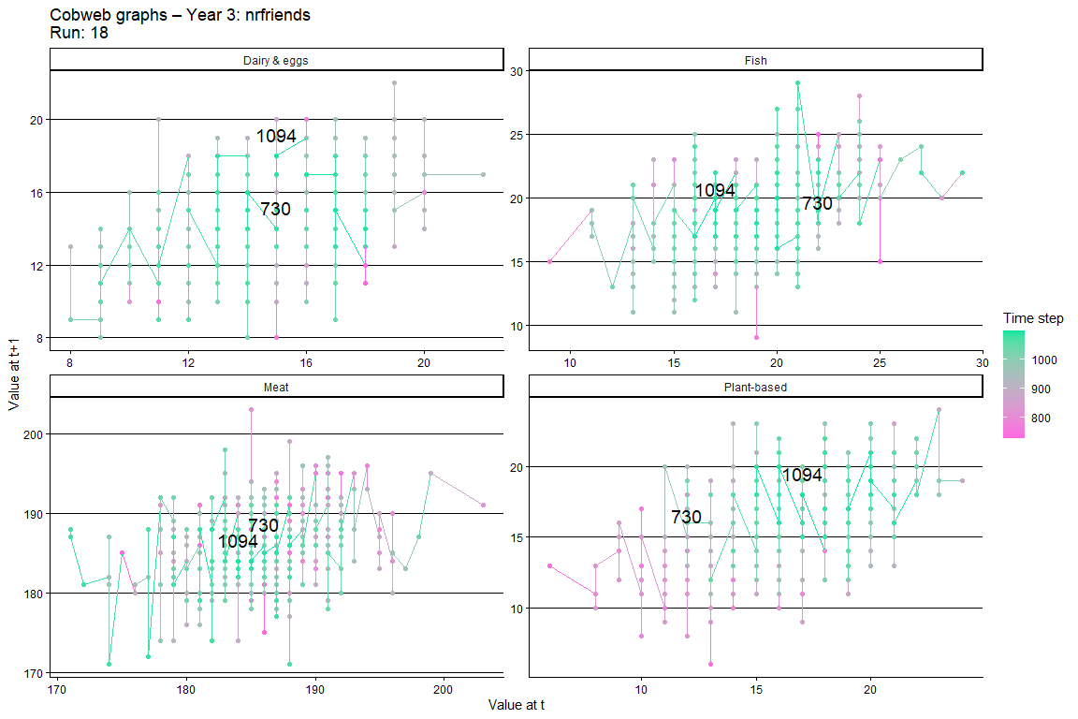
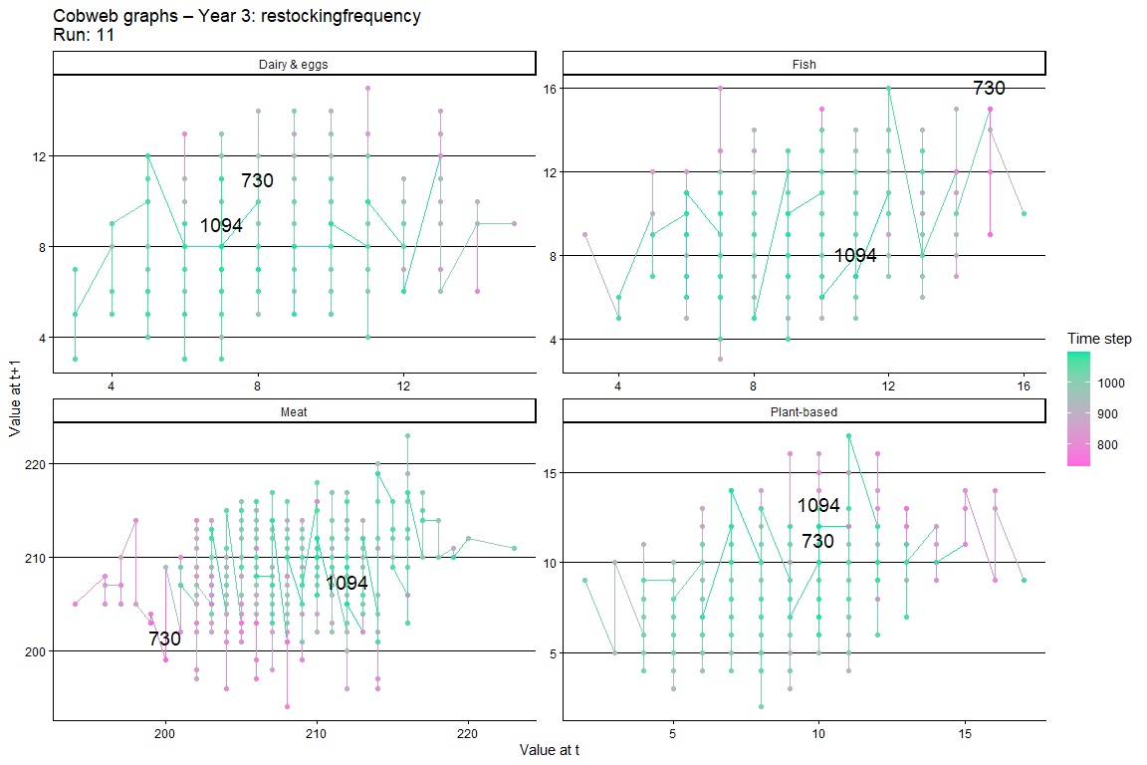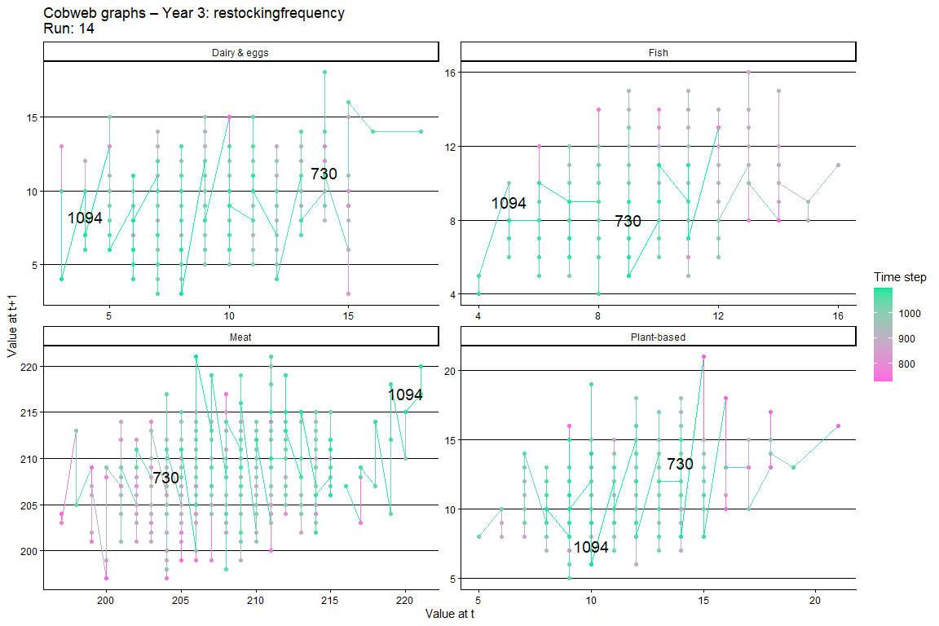

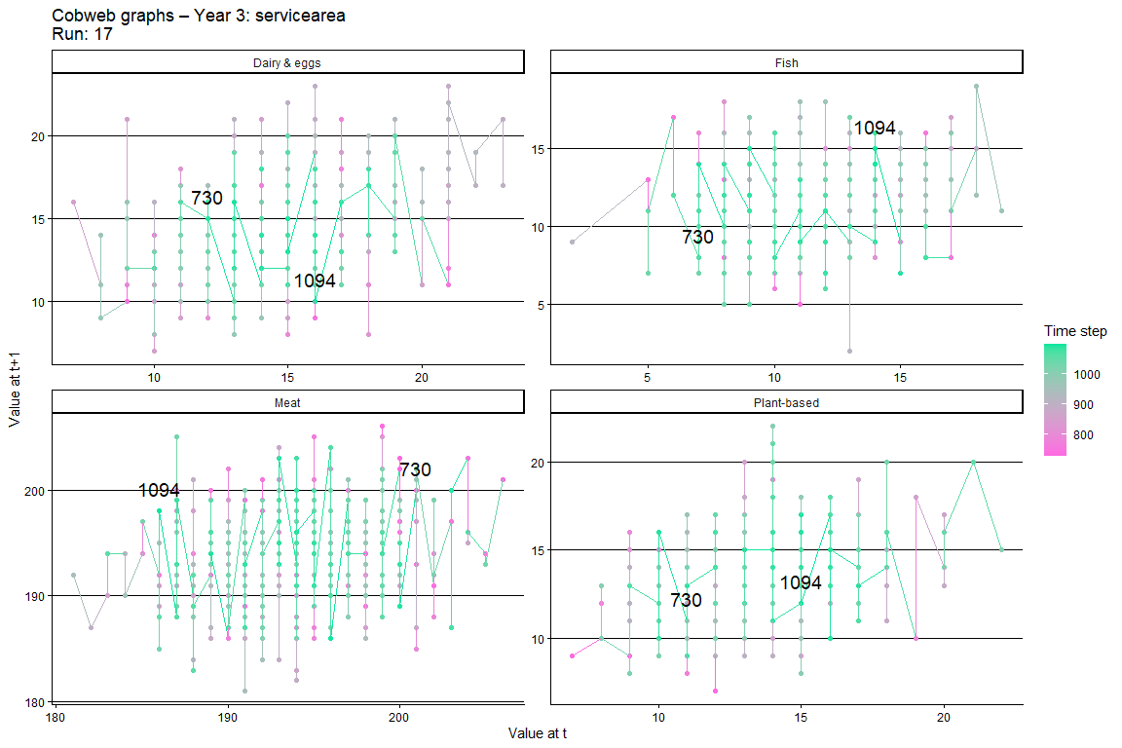
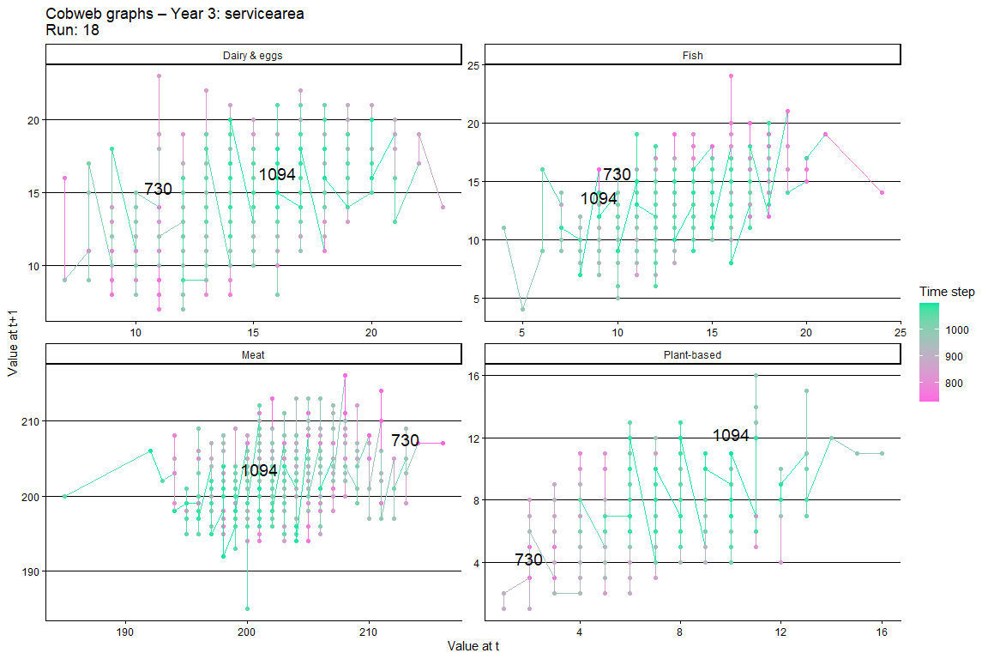

Global sensitivity analysis (PRCC)
For the global sensitivity analysis we used Partial Rank Correlation Coefficient (PRCC), which works best for variables that are linearly related i.e. show a monotonic relationship, and when the controlling variables are not highly correlated. Another reason that PRCC was an appropriate choice pertains to the number of outliers that we observed in the plots from the OFAT sensitivity analysis. Each parameter value is run at least ten times; included input parameters and tested values are shown in Table 3. In the boxplots + violin plots in this section, as well as the plots shown in the OFAT-section, we assessed the monotonic condition for the PRCC. The results are shown in Table 4. Some relationships are a clear monotonic relationship, while others are not, though these relationships are still linear, except for one: the relationship between number of friends and meat meals cooked. The controlling variables are not correlated. The PRCC function is provided in equation (1). Y is the output variable, either a type of meal cooked or an inventory level for one of the four protein sources; X is the variable for which the relationship with Y is tested, either the number of food outlets, the number of friends, or the length of the replenishment cycle. A and B represent the controlling variables. If the number of food outlets is X, then the other two variables are the controlling variables. The term with ρ represents Spearman’s rank correlation coefficient between X and the residuals of Y from the regression on A and B.
( 1 ) | $$PRCC(X,Y|A,B)= ρ_{xy,ab}$$

For interpretating the results of the PRCC we used Figure 1. The monotonic relationship between number of food outlets and meals cooked and inventory levels is minimal. It stands out that the effect of meat shows a weak negative relationship, while the other three protein sources show a positive relationship. A potential explanation is that meat is by far the most common choice – effectively acting as a default, both because of the high inventory levels and because of the high preference in the population. More food outlets provides a larger opportunity for those cook-agents who are intending to buy an alternative to meat to actually make the purchase, because they have the opportunity to change supermarket. As a result, people do not have to resort so often to meat when their alternative is sold out. However, the error bars are rather large, so our explanation is not backed up by strong evidence for a monotonic relationship.
The monotonic relationships between the length of the replenishment cycle and inventory levels are very clear: the less often a food outlet replenishes, the larger the stocks. In addition to the effect of number of food outlets, a less-frequent replenishment results in a higher probability of alternatives to meat being still available in the supermarket, while meat may have been depleted because it is the most popular choice (under baseline conditions).
For number of friends, we observe a clear monotonic relationships with inventory levels. If the number of friends increases, the friendship network becomes denser, so dinner parties are larger. As a result, the probability of having a person with high status that prefers meat, is larger. We should note here that a large network does not necessarily mean that people are more likely to meet a non-meat-eater (if they are a meat-eater). In the case of the MEET-eaters model, the large majority preferring meat strongly determines both the incidence and prevalence of eating meat. With a large demand for meat, the food outlets simply respond because of the dynamic inventory setting.

When grouping together the model outcomes for meat and non-meat in the PRCC sensitivity analysis, the opposing direction of behaviour of meat and non-meat meals and inventory levels becomes more pronounced (Figure 2). In summary, as the majority of the population prefers meat and the food outlets reflect this preference in their inventory levels, in particular the length of the replenishment cycle (i.e. how fast are alternatives to meat replenished) and the number of friends (i.e. how high is the probability of having a high-status person-agent that prefers meat in the dinner party) seem most relevant in determining model outcomes.

Table 3 Parameter values tested for global sensitivity analysis (PRCC)
parameter | values
Initial-nr-food-outlets | 1,2,3,4,5
Nr-friends | 1,2,3,4,5
Restocking-frequency | 1,2,3,4,5

Table 4 Assessment of relationships between input and output variables
input | output | relationship
Initial-nr-food-outlets | Meals cooked | Non-monotonic
Initial-nr-food-outlets | Inventory levels | Non-monotonic
Nr-friends | Meals cooked | Negative
 | Inventory levels | Positive for meat;  Non-monotonic for other protein sources
Restocking-frequency | Meals cooked | Non-monotonic
 | Inventory levels | Positive

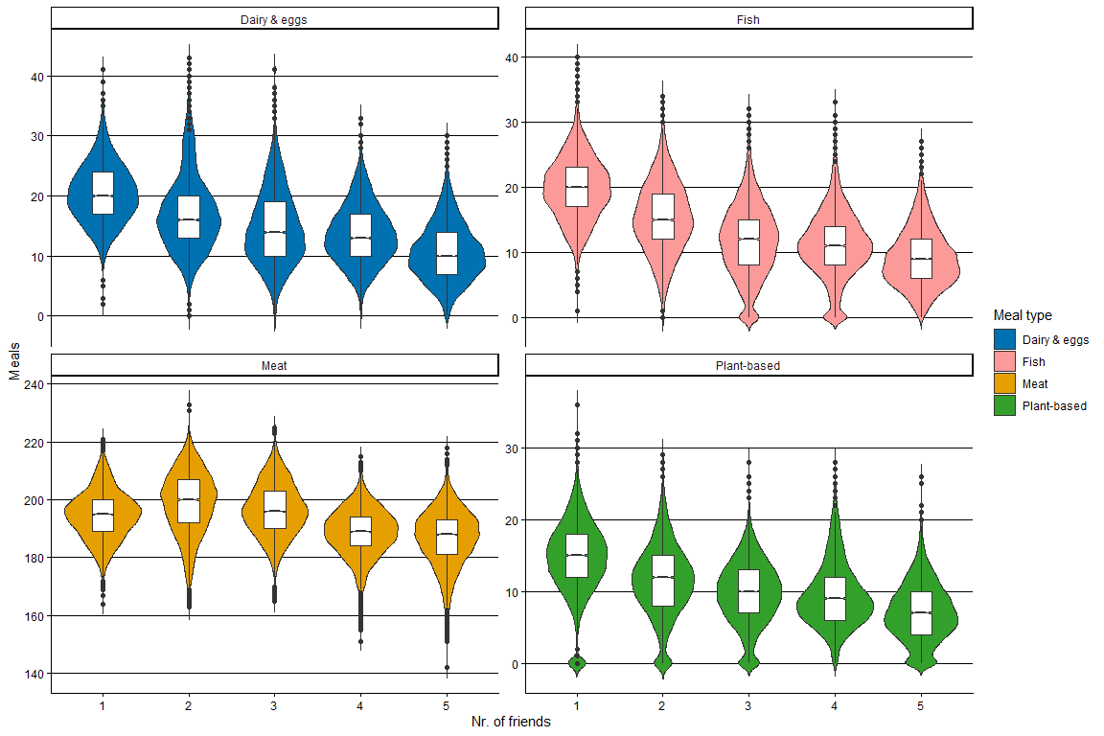
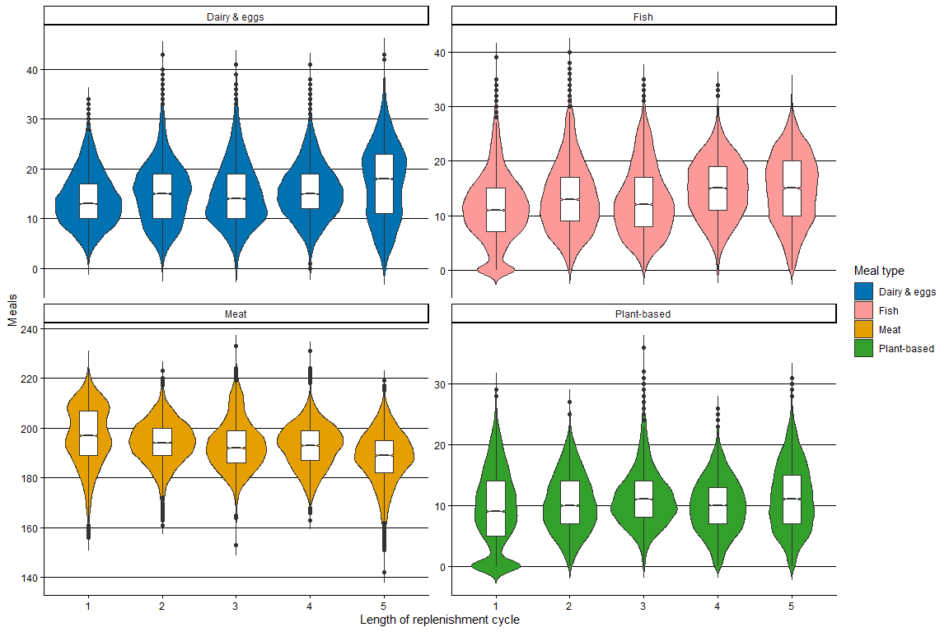

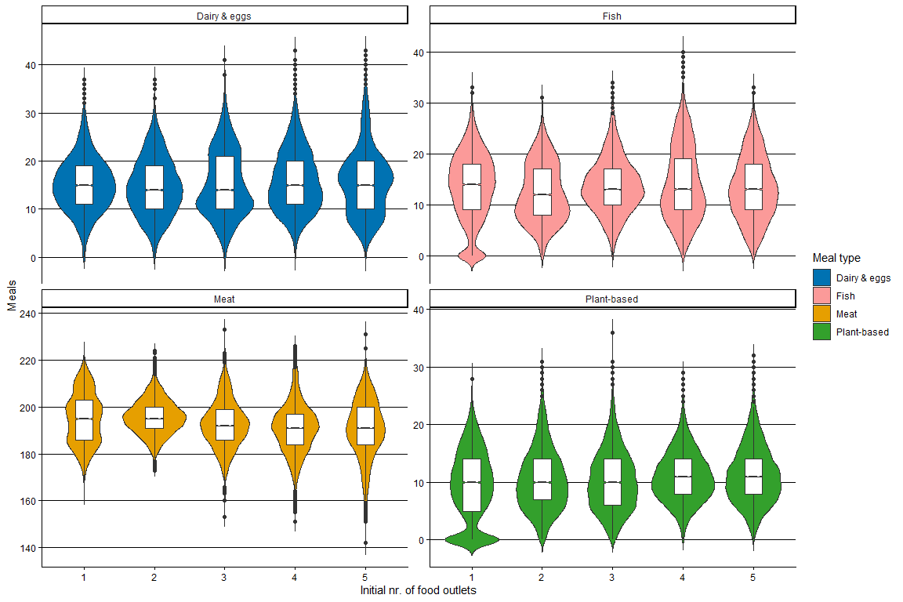
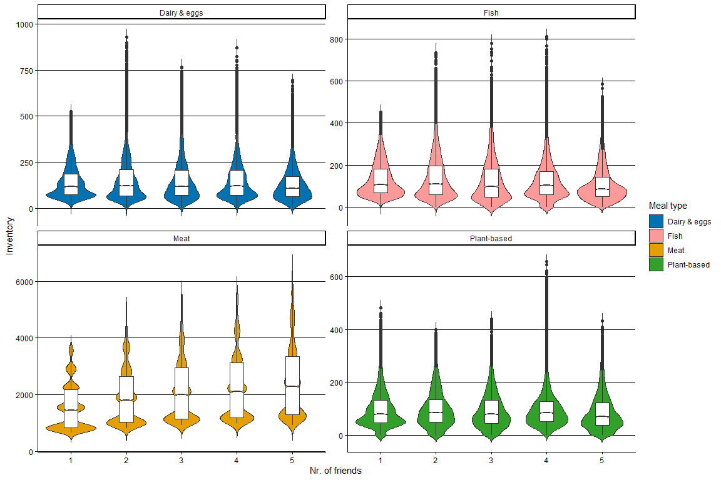

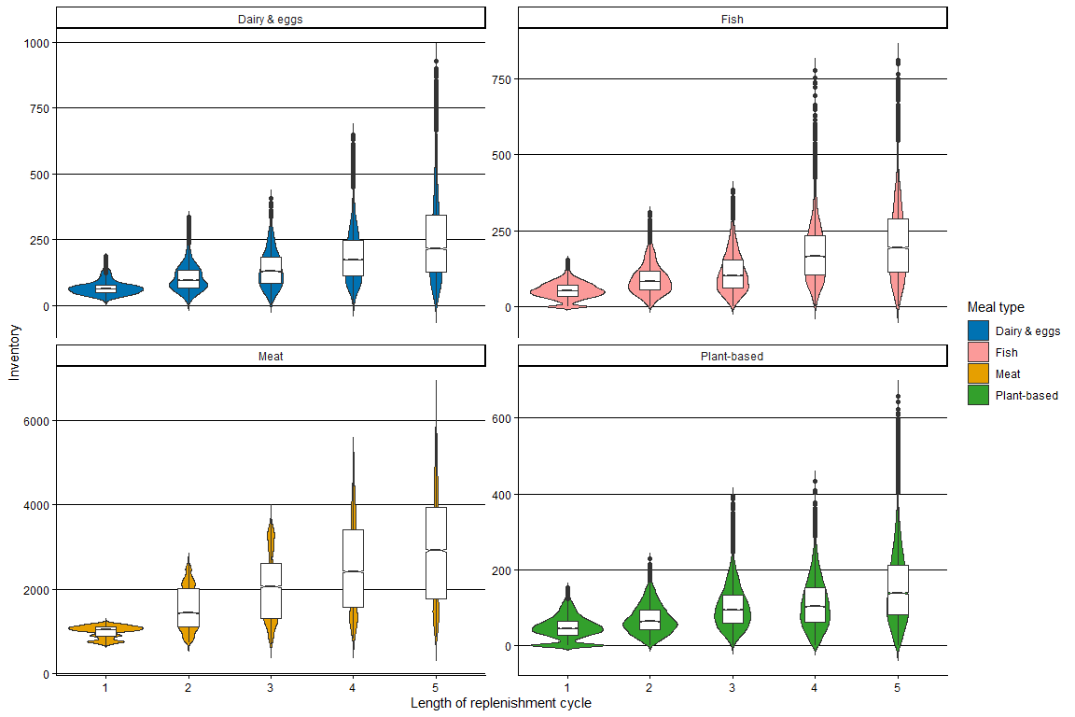
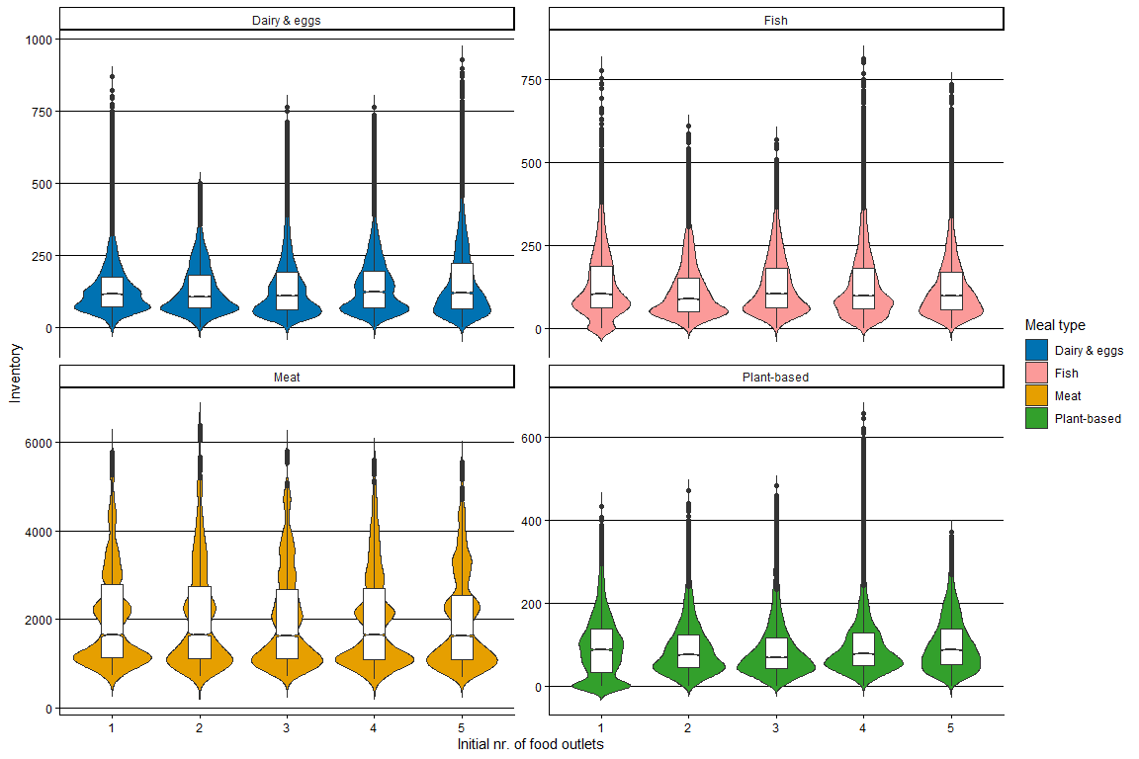
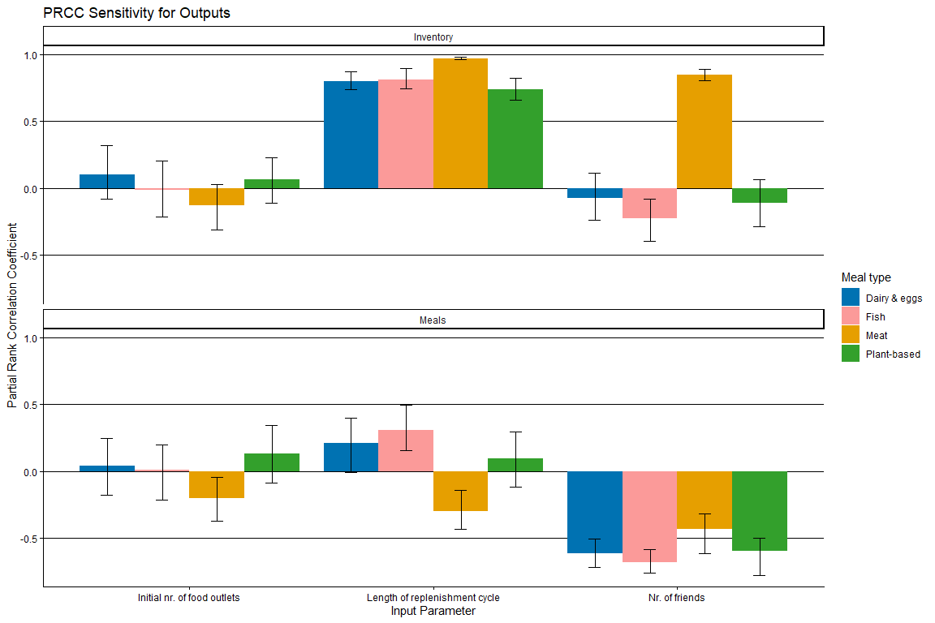
Figure 1 Results from global sensitivity analysis (PRCC) with all four protein sources separated.
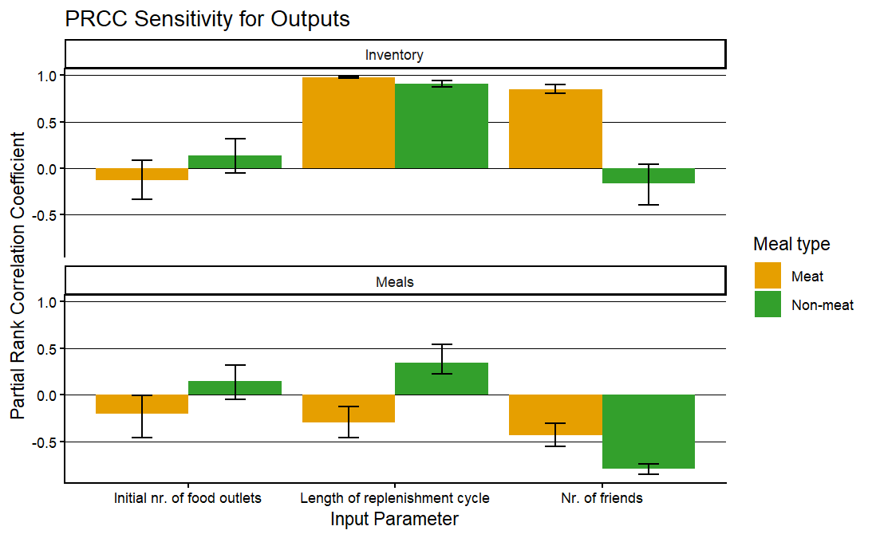
Figure 2 Results for global sensitivity analysis (PRCC) with non-meat (fish, vegetarian, vegan) grouped together.

References
Blokhuis, C. and Polhill, J.G. (2025), 'MEET-eaters. An agent-based model to study the interaction between food retail supply and household demand. ', (v05; https://github.com/Kita2015/abm_households_foodretail).
Broeke, Guus ten, Voorn, George van, and Ligtenberg, Arend (2016), 'Which Sensitivity Analysis Method Should I Use for My Agent-Based Model?', J. Artif. Soc. Soc. Simul., 19,

